
Faculty of Computing
Requirement Analysis Document (RAD) for Industrial project on Hospital Management System
Submitted to the faculty of computing in partial fulfillment of the requirements for the degree of Bachelor of Science in
Information Technology

Group Member’s Name ID Number
- Abemelek Mesfin BDU1504785
- Yonas Alebel BDU1508348
- Tsion Tesfaye BDU1508052

Advisor ፡ Mr. Tesfahun
[2026]
Bahir Dar University, Bahir Dar Institute of Technology

Declaration

The Project is our own and has not been presented for a degree in any other university and all the sources of material used for the project have been duly acknowledged.

Name: Abemelek Mesfin Signature: __

Name: Yonas Alebel Signature: ___
Name: Tsion Tesfaye Signature: ________

Faculty: Computing
Program: Information Technology
Project Title: Smart Hospital Management

This is to certify that I have read this project and that in my supervision and the students’ performance, it is fully adequate, in scope and quality, as a project for the degree of Bachelor of Science.
Name of Advisor: Mr. Tesfahun Signature:

Examining committee members Signature Date

- Examiner1 ____________ ____________
- Examiner2 ____________ ____________

It is approved that this project has been written in compliance with the formatting rules laid down by the faculty.
.

Roles and Responsibilities of the Group Members
Fill the following role assignment matrix and put a tick mark(√) under each member in line with each task to indicate who has participated in carrying out the activities to produce the draft deliverable for discussion to the group so that they will discuss on the issue and come to consensus. Finally each group member will well understand the entire work of the project by sharing experiences among the colleagues.

List of Tasks | List members
 | Abemelek Mesfin | Yonas Alebel | Tsion Tesfaye
Requirement  Documentation Preparation |  | ✔ | ✔
UML Diagram Documentation and  Explanation | ✔
System Design Documentation |  | ✔
Editing, Formatting |  |  | ✔
UI/UX Design & Prototyping | ✔
Final Compilation | ✔
Requirement Gathering |  | ✔ | ✔

Acknowledgment
First and foremost, we would like to express our sincere gratitude to Almighty God for granting us the strength, patience, and guidance necessary to successfully complete this final year project. We would like to extend our deepest appreciation to our project adviser for their continuous guidance, constructive feedback, and professional support throughout the development of this project. Their valuable advice and encouragement played a significant role in shaping the direction, quality, and completeness of this work. We are also grateful to the instructors and staff members of Computing Faculty for providing us with the academic knowledge, resources, and learning environment that made this project possible. Their dedication and commitment to teaching have greatly contributed to our academic and professional development. Special thanks go to our classmates and friends for their cooperation, discussions, and moral support during the course of this project. Their ideas, feedback, and encouragement were highly motivating. Finally, we would like to express our heartfelt appreciation to our families for their unconditional love, patience, and continuous support throughout our academic journey. Their encouragement and understanding have been a constant source of motivation and strength.

List of Acronyms
API: Application Programming Interface

BR: Business Rule

CBHI: Community Based Health Insurance CPOE: Computerized Physician Order Entry CRC: Class Responsibility Collaboration DHIS2: District Health Information Software 2
eCHIS: electronic Community Health Information System

EMR: Electronic Medical Record

ERD: Entity Relationship Diagram

HMIS: Health Management Information System

ID: Identification / Identifier

JS: JavaScript

MoH: Ministry of Health

OOAD: Object-Oriented Analysis and Design RAD: Requirement Analysis Document RBAC: Role-Based Access Control
RDD: Requirement Design Document REST: Representational State Transfer UC: Use Case
UI: User Interface

UML: Unified Modeling Language

List of Figures Pages

Figure 2.1. General Use Case Diagram ---------------------------------------------------------------------- 19
Figure 2.2. Triage Use Case -------------------------------------------------------------------------------------- 20
Figure 2.3. Reception Use Case ---------------------------------------------------------------------------------- 20
Figure 2.4. Doctor Use Case -------------------------------------------------------------------------------------- 20
Figure 2.5. Pharmacy Use Case ---------------------------------------------------------------------------------- 21
Figure 2.6. Billing Use Case --------------------------------------------------------------------------------------- 21
Figure 2.7. Nurse Use Case ---------------------------------------------------------------------------------------- 21
Figure 2.8. Laboratory Use Case ---------------------------------------------------------------------------------- 21
Figure 2.9. Admin Use Case --------------------------------------------------------------------------------------- 22
Figure 2.10 Login Page -------------------------------------------------------------------------------------------- 29
Figure 2.11 Admin Dashboard --------------------------------------------------------------------------------- 29
Figure 2.12 Doctor Dashboard ------------------------------------------------------------------------------ 30
Figure 2.13 Payment Page ------------------------------------------------------------------------------- 30
Figure 2.14 Triage State Diagram ---------------------------------------------------------------------------- 31
Figure 2.15 Reception State Diagram ------------------------------------------------------------------------ 31
Figure 2.16 Doctor State Diagram ---------------------------------------------------------------------------- 32
Figure 2.17 Nurse State Diagram ----------------------------------------------------------------------------- 32
Figure 2.18 Pharmacy State Diagram ------------------------------------------------------------------------- 33
Figure 2.19 Laboratory State Diagram ------------------------------------------------------------------------ 33
Figure 2.20 Billing State Diagram ----------------------------------------------------------------------------- 34
Figure 2.21 Admin State Diagram ----------------------------------------------------------------------------- 34
Figure 2.22 Triage Activity Diagram ---------------------------------------------------------------------------- 35
Figure 2.23 Reception Activity Diagram ------------------------------------------------------------------------ 35
Figure 2.24 Doctor Activity Diagram ---------------------------------------------------------------------------- 36
Figure 2.25 Nurse Activity Diagram ----------------------------------------------------------------------------- 37
Figure 2.26 Pharmacy Activity Diagram ------------------------------------------------------------------------ 37
Figure 2.27 Laboratory Activity Diagram ------------------------------------------------------------------------38
Figure 2.28 Billing Activity Diagram ---------------------------------------------------------------------------- 38
Figure 2.29 Admin Activity Diagram ---------------------------------------------------------------------------- 39
Figure 2.30 Triage Sequence Diagram --------------------------------------------------------------------------- 40
Figure 2.31 Reception Sequence Diagram ---------------------------------------------------------------------- 41
Figure 2.32 Doctor Sequence Diagram -------------------------------------------------------------------------- 42
Figure 2.33 Nurse Sequence Diagram --------------------------------------------------------------------------- 43
Figure 2.34 Pharmacy Sequence Diagram ---------------------------------------------------------------------- 44
Figure 2.35 Laboratory Sequence Diagram --------------------------------------------------------------------- 45
Figure 2.36 Billing Sequence Diagram -------------------------------------------------------------------------- 46
Figure 2.37 Admin Sequence Diagram -------------------------------------------------------------------------- 47
Figure 2.38 Analysis Class Diagram ----------------------------------------------------------------------------- 48
Figure 2.39 Logic Model Diagram -------------------------------------------------------------------------------- 49
Figure 3.1 Component Model ------------------------------------------------------------------------------------ 57
Figure 3.2 Deployment Model ----------------------------------------------------------------------------------- 57
Figure 3.3 Deployment Model ----------------------------------------------------------------------------------- 58
Figure 3.4 Persistent Model -------------------------------------------------------------------------------------- 59
Figure 3.5 Login Page -------------------------------------------------------------------------------------------------- 60
Figure 3.6 Admin Dashboard --------------------------------------------------------------------------------------- 60
Figure 3.7 Doctor Dashboard ------------------------------------------------------------------------------------ 61
Figure 3.8 Payment Page ------------------------------------------------------------------------------------ 61

List of Tables Pages

Table 1.1 Research Methodology Overview ------------------------------------------------------------------------- 3
Table 1.2 Analysis and Design Approach ---------------------------------------------------------------------------- 4
Table 1.3 Technology Stack and Implementation Approach ---------------------------------------------------- 5
Table 1.4 Software Development Approach ------------------------------------------------------------------------- 5
Table 2.1. Triage Use Case ----------------------------------------------------------------------------------------------- 22
Table 2.2. Reception Use Case ------------------------------------------------------------------------------------------- 23
Table 2.3. Doctor Use Case ----------------------------------------------------------------------------------------------- 23
Table 2.4. Nurse Use Case ------------------------------------------------------------------------------------------------ 24
Table 2.5. Pharmacy Use Case ------------------------------------------------------------------------------------------- 24
Table 2.6. Laboratory Use Case ------------------------------------------------------------------------------------------ 25
Table 2.7. Billing Use Case ------------------------------------------------------------------------------------------------ 25
Table 2.8. Admin Use Case ------------------------------------------------------------------------------------------------ 26
Table 2.9. Business Rule List ---------------------------------------------------------------------------------------------- 27
Table 2.10. Business Rules Mapped to System Functions --------------------------------------------------------- 28
Table 2.11. Business Rules by User Role ------------------------------------------------------------------------------- 28
Table 2.12 Core Classes and Their Responsibilities ---------------------------------------------------------------- 48
Table 2.13 Logic Model Table -------------------------------------------------------------------------------------------- 49
Table 2.14 Patient CRC Card ---------------------------------------------------------------------------------------------- 52
Table 2.15 Visit CRC Card ------------------------------------------------------------------------------------------------- 52
Table 2.16 TriageRecord CRC Card -------------------------------------------------------------------------------------- 52
Table 2.17 Diagnosis CRC Card ------------------------------------------------------------------------------------------- 53
Table 2.18 Prescription CRC Card ---------------------------------------------------------------------------------------- 53
Table 2.19 LabRequest CRC Card ---------------------------------------------------------------------------------------- 53
Table 2.20 LabResult CRC Card ------------------------------------------------------------------------------------------ 53
Table 2.21 Medication CRC Card ----------------------------------------------------------------------------------------- 53
Table 2.22 Bill CRC Card --------------------------------------------------------------------------------------------------- 54
Table 2.23 Payment CRC Card --------------------------------------------------------------------------------------------- 54
Table 2.24 User CRC Card -------------------------------------------------------------------------------------------------- 54
Table 2.25 Admin CRC Card ----------------------------------------------------------------------------------------------- 54
Table 2.26 Report CRC Card ----------------------------------------------------------------------------------------------- 54
Table 2.27 Change Cases ---------------------------------------------------------------------------------------------------- 55

Abstract
Healthcare institutions, particularly hospitals, face significant challenges in managing patient records, clinical workflows, and billing processes efficiently due to the continued reliance on manual and semi- digital systems. These challenges often result in long waiting times, data inconsistencies, poor coordination between departments, and difficulties in generating accurate reports. To address these issues, this project proposes and develops, an integrated hospital management system designed to automate and streamline core hospital operations. The system focuses on key hospital processes including patient registration, visit management, medical checkup documentation, billing, payment processing, and administrative reporting. The system supports multiple user roles such as administrators, receptionists, doctors, nurses, and cashiers, with role- based access control to ensure data security and proper authorization. By centralizing hospital data and standardizing workflows, the system improves data accuracy, operational efficiency, and service delivery. The system is designed as a web-based application using modern technologies and structured software engineering principles. Unified Modeling Language (UML) diagrams were employed during system analysis and design to ensure clarity, correctness, and maintainability. The proposed solution aims to reduce paperwork, minimize human error, enhance interdepartmental communication, and provide timely access to critical information for decision-making. Overall, the hospital management system demonstrates how digital solutions can improve healthcare service efficiency and reliability. The project serves as a practical and scalable solution that can be adapted by small to medium-sized healthcare institutions seeking to modernize their operations.

Table of Contents
Declaration 2
Roles and Responsibilities of the Group Members 3
Acknowledgment 4
List of Acronyms 5
List of Figures Pages 6
Abstract 8
CHAPTER ONE 1
1.1 Background of the Study 1
1.2 Statement of the Problem 1
1.3 Objectives 2
1.3.1 General Objective 2
1.3.2 Specific Objectives 2
1.4 Methodology 3
1.4.1 Research Methodology 3
1.4.2 Analysis and Design Methodology 3
1.4.3 Implementation Methodology 4
1.5 Feasibility Study 6
1.5.1 Technical Feasibility 6
1.5.2 Economic Feasibility 6
1.5.3 Operational Feasibility 7
1.5.4 Legal and Ethical Feasibility 7
1.5.5 Schedule Feasibility 7
1.6 Beneficiaries of the Project 7
1.7 Limitations of the Project 8
1.8 Scope of the Project 9
1.8.2 Patient Registration 9
1.8.3 Patient Monitoring Workflow 10
1.8.4 Digital Recording of Checkups 10
1.8.5 Laboratory Management Module 10
1.8.6 Pharmacy Management Module 10
1.8.7 Automated Billing 10
1.8.8 Role-Based Access Controls 10
1.8.9 Report Generation 11
1.8.10 Web and Mobile System Integration 11
1.8 Organization of the Project 11
CHAPTER TWO 13
SYSTEM FEATURES 13
2.1 The Existing System 13
2.1.1 Overview of Current Operational Framework 13
2.1.2 Patient Registration and Intake Workflow 13
2.1.3 Medical Record Keeping and Documentation 13
2.1.4 Patient Flow and Service Tracking 14
2.1.5 Billing and Financial Management 14
2.2 Proposed System 15
2.2.1 Administrative Efficiency and Staff Workflow Optimization 15
2.2.2 Clinical Safety Enhancement 15
2.2.3 Faster Patient Flow and Real-Time Tracking 15
2.2.4 Automated Billing and Financial Transparency 16
2.2.5 Overcoming Barriers to Digital Adoption 16
2.3.Requirement Analysis 16
2.3.1 Functional Requirements 16
2.3.2 System Use case 19
2.3.3. Business Rule Documentation 27
2.3.4. User Interface prototype 29
2.3.5. State chart diagram 31
2.3.6. Activity Diagram 35
2.3.7. Sequence diagram 40
2.3.8. Analysis Class Model 48
2.3.9. Logic model 49
2.4 Nonfunctional requirement 50
2.4.1 Performance Requirements 50
2.4.2 Security Requirements 50
2.4.3 Usability Requirements 50
2.4.4 Reliability and Availability Requirements 50
2.4.5 Scalability Requirements 50
2.4.6 Maintainability Requirements 51
2.4.7 Portability Requirements 51
2.4.8 Legal and Ethical Requirements 51
2.5 System Requirements 51
2.5.1 Hardware Requirements 51
2.5.2 Software Requirements 51
2.6 Key abstraction with CRC (Class Responsibility Collaborator) analysis 52
2.6.1 CRC Cards 52
2.6.3 User Interface Prototyping 55
Chapter 3: System Design 56
3.1. Architectural Design 57
3.1.1. Component Modeling 57
3.1.2. Deployment Modeling 57
3.2. Detail Design 58
3.2.1. Design Class Model 58
3.2.2 Persistent Model 59
3.3. User Interface Design 60
Reference 62
Appendix A: Interview Questions 63
Appendix B: Interview Summary 64

CHAPTER ONE

Background of the Study
Healthcare institutions play a vital role in society by providing medical services, diagnosis, and treatment to patients. However, the efficiency and quality of healthcare delivery are significantly influenced by how well patient data, medical records, appointments, and billing information are managed. In many developing countries, including Ethiopia, hospitals and clinics still rely heavily on manual workflows such as paper-based registration books, physical patient cards, handwritten diagnosis notes, and manual billing sheets. These traditional methods are prone to errors, easily damaged, difficult to organize, and slow to update, making it challenging for healthcare providers to maintain consistent and reliable records.

As patient flow increases, manual systems create bottlenecks that delay treatment and reduce service quality. Common challenges include misplaced patient files, long waiting times, miscommunication between departments, and inconsistent billing practices. Furthermore, the absence of real-time patient tracking makes it difficult for nurses and doctors to know where a patient is in the service process, often leading to confusion, duplication of services, or unnecessary delays. Hospitals also struggle to generate accurate daily or monthly reports for planning, resource allocation, or performance monitoring.

The growing demand for efficient healthcare services makes digital transformation an essential step toward modernizing hospital workflows. A centralized, automated system that can manage patient registration, track movement through different departments, record medical consultations, and automate billing would significantly improve operational efficiency. Modern technologies such as web applications, mobile applications, and REST-based APIs offer robust solutions to integrate hospital operations into a single unified platform.

Dose Smart Hospital Management and Patient Tracking System is proposed as a digital solution that addresses these operational challenges. The system aims to streamline the workflow of hospitals by providing an integrated platform for patient management, clinical data handling, billing automation, and administrative reporting. By adopting this system, healthcare institutions can enhance accuracy, reduce delays, improve patient satisfaction, and support better decision-making through data-driven insights.

Statement of the Problem
Hospitals and clinics are environments where accuracy, speed, and coordination directly affect patient outcomes. Yet despite the increasing demand for organized healthcare, many hospitals continue to use traditional methods for managing patient information and daily operations. These methods typically involve paper-based patient cards, physical logbooks, manual checkup notes, doctor schedules written in notebooks, and handwritten billing slips. Such fragmented and outdated systems create a chain of inefficiencies that affect every stakeholder in the healthcare delivery process. One of the most critical issues is the lack of a unified and reliable patient identification and record system. Patient cards are easily damaged, misplaced, or inconsistently updated. When a returning patient visits the hospital, staff often struggle to retrieve previous records, leading to incomplete medical history and repeated questions during every visit. This not only wastes time but also compromises the continuity of care.

Another major challenge is the absence of real-time patient flow tracking. Once a patient registers at the reception, there is no structured way to monitor their movement between departments. Receptionists cannot determine how many patients are waiting for a particular doctor, nurses cannot see which patients have completed payment, and doctors often don't know how many patients are ahead in their queue. This lack of visibility leads to unnecessary waiting, miscommunication, and confusion.

Additionally, medical consultations and checkup details are often written manually on paper, making it difficult for other staff members to access patient data quickly. Over time, these papers are lost, damaged, or become unreadable. Without a digital record, doctors cannot easily review past diagnoses or treatments.

The billing process also suffers from inefficiencies. Manual calculations result in errors, inconsistent pricing, and disputes between patients and staff. It becomes difficult for administrators to reconcile daily income or verify completed payments. Financial transparency becomes compromised.

Hospital administrators further struggle due to the absence of automated reporting tools. They cannot easily determine patient inflow patterns, doctor performance, or revenue trends, making strategic planning and decision-making nearly impossible.

Therefore, the core problem is the lack of an integrated, real-time, digital system that connects patient registration, tracking, checkup documentation, and billing into a single workflow. Dose aims to address these challenges by providing a unified platform that replaces fragmented manual processes with a smart, automated hospital management and patient tracking system.

Objectives

General Objective
The general objective of this project is to design and develop an integrated hospital management.

Specific Objectives
The specific objectives of this project are:
      - Gather requirements for a digital hospital management system based on research.
      - Design and implement a digital patient registration module.
      - Implement a visit lifecycle management system (create, update status, close).
      - Develop automated billing and payment processing with accurate bill generation.
      - Develop a mobile interface for doctors and nurses for real-time clinical updates.
      - Model the system using UML diagrams (use case, activity, sequence, state, class).
      - Implement a clinical triage module for patient categorization before registration.
      - Integrate a digital laboratory module for test requests and result processing.
      - Develop a prescription-based pharmacy module for controlled medication dispensing.
      - Integrate clinical, diagnostic, and pharmacy workflows into a unified system.

Methodology

Research Methodology
The research phase adopts a qualitative approach, focusing on understanding the real working environment of small and medium healthcare facilities. Observational analysis allows identifying how patients move within the hospital and where delays typically occur. Informal discussions with individuals familiar with clinical workflows provide insights into practical issues such as lost patient cards, miscommunication, and billing inconsistencies. Additionally, academic and online resources were reviewed to compare existing systems and identify gaps that Dose can improve upon. These combined insights form the foundation for defining functional requirements and guiding the direction of the system.

Activity | Description | Purpose
Observation | Visiting healthcare centers or analyzing typical hospital workflows through online references and simulations. | To understand real-life patient flow, registration processes, and checkup tracking challenges.
Informal Interviews | Discussing with individuals who have experience in hospital environments (nurses, receptionists, or administrative staff if available). | To gather practical insights about existing problems and user needs.
Document Review | Reviewing academic papers, articles, and online documentation on hospital information systems. | To understand current trends, common system features, and limitations in existing solutions.
Problem Identification | Synthesizing collected information to identify workflow bottlenecks and technology gaps. | To clearly define the core issues that the system will solve.
Table 1.1 Research Methodology Overview

Analysis and Design Methodology
The analysis and design phase uses Object-Oriented Analysis and Design (OOAD) to break down the system into components and represent system behavior visually. Requirements are analyzed through user stories to understand the tasks doctors, nurses, and receptionists perform. UML diagrams are then used to represent the interactions between users and the system. The ERD defines how patient data, medical history, billing, and tracking records relate to each other. Lastly, wireframes help conceptualize how both the mobile and web interfaces will look and function, ensuring intuitive user experience before coding begins.

Activity | Tools / Techniques | Outcome
Requirement Analysis | Requirement gathering sessions, reviewing workflows, user story creation | Clear functional and non-functional requirements
Use Case Modeling | UML Use Case Diagrams | Identification of system boundaries and user roles
Workflow Modeling | Activity diagrams, sequence diagrams | Visualization of patient journey and system interactions
Database Design | ERD (Entity Relationship Diagram), relational modeling | Structured database schema for storing all system data
Interface Wire framing | UI mockups, low-fidelity sketches | Initial layout for mobile and web interfaces before development
Table 1.2 Analysis and Design Approach

Implementation Methodology
The implementation follows an iterative and modular development approach, where the system is built in small manageable modules. The backend is developed using Django REST Framework to ensure scalability and secure handling of medical data. PostgreSQL is selected for its robustness and ability to handle relational healthcare records.

The web dashboard is built with React, allowing administrative users to manage data efficiently through a user-friendly interface. Meanwhile, the mobile application is built in Flutter to support nurses and doctors working on the ground, enabling quick access to patient lists, checkup forms, and updates on patient status.

During each development cycle, the newly created module is tested to ensure stability before moving to the next one. This approach ensures the system grows gradually without overwhelming errors. After final testing, the project will be deployed locally or on a cloud server for presentation and demonstration.

Component | Technology Used | Purpose in the System
Backend API | Django REST Framework | Handles business logic, data processing, authentication, and role-based access
Database | PostgreSQL | Stores patient records, checkups, billing, and tracking details securely
Web Application | React JS | Used by administrators and receptionists for managing registration, reports, and billing
Mobile Application | Flutter | Used by doctors and nurses for real-time patient tracking and checkup recording
Deployment & Hosting | Local server or cloud platform | Hosts the API and database to enable multi-device access
Table 1.3 Technology Stack and Implementation Approach

Phase | Description
Module Planning | System divided into modules such as registration, tracking, checkup, billing, and reporting
Iterative Development | Each module implemented in cycles: design → development → test → refine
API Integration | Connecting the web and mobile apps to the backend using REST APIs
Testing | Unit testing, integration testing, and user acceptance testing using simulated data
Deployment | Preparing a stable version for demonstration and documentation
Table 1.4 Software Development Approach

Feasibility Study
The feasibility analysis for this project is conducted from five major perspectives: technical, economic, operational, legal/ethical, and schedule feasibility.

Technical Feasibility
From the user’s perspective, the system is technically feasible because it is designed to work with commonly available hardware and software. Hospital staff such as receptionists, doctors, nurses, and cashiers can access the system using standard desktop computers, laptops, tablets, or smartphones without the need for specialized equipment. The web application runs on modern browsers, while the mobile application supports Android devices, which are widely used in local healthcare settings. The system architecture is client–server based, meaning users do not need to install complex software locally. After deployment, users only interact with a simple user interface, while all processing, data storage, and security controls are handled on the server. This reduces the technical burden on hospital staff and minimizes maintenance complexity.

From the user’s experience, the system responds quickly to actions such as registering patients, updating visit status, recording checkups, and generating bills. In terms of system reliability, users can continue normal operations as long as the local network or internet connection is available. The design also considers environments with unstable connectivity by allowing short interruptions without data loss during basic operations. This makes the system suitable for hospitals with limited infrastructure.
Regarding usability and learnability, the system uses intuitive interfaces that match existing hospital workflows. Users do not require advanced technical skills; basic computer or smartphone knowledge is sufficient. Minimal training is enough for staff to adapt to the system, which increases acceptance and reduces operational resistance after deployment. Maintenance and future updates are also technically feasible from the user’s side. Since the system is centrally managed, updates or improvements can be applied on the server without disrupting user devices. This ensures continuity of service and long-term usability. Overall, from the post-deployment user perspective, the system is technically feasible because it is accessible, reliable, easy to use, and compatible with the technological capabilities of small and medium-sized hospitals.

Economic Feasibility
From the user’s point of view, the project is economically feasible because it does not require users or the hospital to invest in expensive software or tools. All necessary technologies and tools are open-source and free to use. Users can access and use the system without purchasing licenses, and the initial deployment can be done locally without cost. Even if the hospital decides to host the system on a cloud server in the future, low-cost options are available. Because the project is for academic purposes and demonstrations, it does not create any financial burden for students, staff, or the institution. Therefore, users can adopt the system without incurring significant expenses.

Operational Feasibility
From the user’s perspective, the system is operationally feasible because it fits well into the daily workflow of hospital staff. Currently, users perform many tasks manually, which takes more time and increases the chance of errors. The digital system will simplify these tasks by providing organized workflows for registration, triage, consultations, lab tests, pharmacy, and billing. The interface is designed to be intuitive and role-based, so each user only sees the functions relevant to their work. Although users may need time to adjust and receive basic training, the system is simple enough for quick adoption. In a simulated hospital environment, users can operate the system efficiently. Overall, the system improves work productivity and reduces manual workload, making it operationally feasible.

Legal and Ethical Feasibility
From the user’s perspective, the system is legally and ethically feasible because it protects patient privacy and sensitive information. Users such as doctors, nurses, and administrative staff can access only the information needed for their roles, reducing the risk of unauthorized data exposure. The system uses secure login and role-based access control, ensuring that patient records and financial information remain confidential. During the academic development phase, no real patient data is used, which minimizes ethical concerns. Users can trust that the system follows standard confidentiality practices and complies with general ethical requirements for healthcare data handling.

Schedule Feasibility
From the user’s perspective, the system is schedule-feasible because it is designed to deliver the most important hospital functions within the available time. Users will benefit from the core modules such as patient registration, visit tracking, clinical recording, billing, and reporting, which are prioritized to ensure timely completion. Secondary features are intentionally excluded to prevent delays and ensure that the system can be implemented and tested within the academic timeline. The development approach uses manageable phases, allowing users to gradually adopt the system as features are delivered. With this focused scope and clear timeline, users can expect a working system within the final-year project schedule.

Beneficiaries of the Project
The implementation of Dose will directly and indirectly benefit multiple stakeholders within the healthcare ecosystem:

Hospital Administrators

Administrators will gain real-time access to patient statistics, staff workload, and financial reports. With automated reporting and improved data accuracy, they can make better decisions regarding staffing, resource allocation, and service improvement. Operational transparency will be enhanced, reducing opportunities for fraud or financial mismanagement.

Doctors and Medical Professionals

Doctors will benefit from instant access to patient medical history, previous visit details, prescriptions, and diagnoses. They will no longer rely on handwritten notes or physical files. This improves diagnostic accuracy, speeds up consultations, and reduces errors caused by missing or incomplete information.

Nurses and Support Staff

Nurses gain clarity on which patients are waiting, which are currently being examined, and which require follow-up procedures. This improves coordination between wards and departments. It also helps staff manage time more effectively.

Receptionists and Cashiers

Receptionists can register patients faster and retrieve patient data instantly. Cashiers can rely on automated billing that calculates charges accurately based on services provided. This reduces mistakes and speeds up the payment process.

Patients and Families

Patients experience shorter waiting times, smoother communication, and more organized service delivery. Their medical records remain securely stored, ensuring better continuity of care. Families benefit from greater clarity in billing and follow-up instructions.

Healthcare Institutions (Long-term Benefit)

The system supports scalability and modernization, enabling hospitals to gradually build a fully digital healthcare environment. Future integrations with labs, pharmacies, or insurance systems become easier.

Limitations of the Project
Although aims to provide a robust and practical hospital management and patient tracking system, several limitations are expected during its development and implementation. These limitations arise from technical, organizational, ethical, and operational constraints that may influence the scope and functionality of the system.

- Technical Limitation: the project is limited to core system functionalities due to development time and academic scope. The system implements essential modules such as patient registration, visit tracking, clinical documentation, billing, and reporting. However, advanced system capabilities such as artificial intelligence based decision support, predictive analytics, and large- scale data optimization are not included. The system architecture is designed for single-facility deployment. Multi-hospital or regional scalability, load balancing, and distributed data synchronization were not implemented, as they require infrastructure and testing beyond the project’s capacity. Additionally, interoperability with external health systems is limited. While the system conceptually aligns with national health information systems, full real-time integration through standardized health data exchange protocols was outside the project scope.

- Organizational Limitations: the project assumes well defined user roles and workflows within the hospital. The system is designed based on typical role responsibilities (administrator, receptionist, doctor, nurse, cashier, laboratory technician, triage and pharmacist). Variations in organizational structure or informal workflow practices are not fully accommodated. The project also limits customization of workflows. While core processes are supported, extensive organizational configuration, such as department-specific rules or policy-based automation, was not implemented to maintain system simplicity and consistency. Furthermore, organizational change management—such as staff training programs and adoption strategies—is not handled by the system itself, as these depend on internal institutional policies rather than software functionality.

- Ethical Limitation: the project prioritizes basic data protection and access control, but does not fully implement advanced ethical compliance mechanisms. Features such as detailed consent management, patient-controlled data access, and full audit trails were limited due to time constraints. The system handles sensitive health information; however, ethical considerations such as long-term data governance and cross-institutional data sharing are not fully addressed in the current implementation. Additionally, the system avoids automated medical decision-making to prevent ethical risks. As a result, clinical decisions remain entirely dependent on healthcare professionals, limiting functional automation in diagnosis or treatment recommendations.

- Operational Limitation: the system supports standard patient flow scenarios. Complex operational cases such as emergency prioritization, mass casualty handling, or parallel departmental workflows are not fully modeled. The reporting and analytics module focuses on descriptive and trend-based analysis. Real-time dashboards and operational forecasting were not included, limiting advanced operational insights. The project also limits long-term operational evaluation. Since deployment is simulated, continuous performance monitoring, user behavior analysis, and system optimization over extended periods are not covered.

Scope of the Project
The scope of this project clearly defines what will include and what it will intentionally exclude. Due to limited time and resources, the system focuses on essential hospital operations that directly impact efficiency, patient flow, and service delivery.

    - Triage Management Module
This module will support the assessment and categorization of all patients before registration. It will enable dedicated triage officers to classify patients using a standardized five-level priority system and record triage information digitally to support clinical decision-making and patient flow management.

Patient Registration
The system will allow hospital receptionists to register new patients, collect basic demographic information, and assign a unique patient ID. All patient records will be stored digitally, with full support for editing, updating, and retrieving past visit histories.

Patient Monitoring Workflow
A major feature of the system is monitoring of patient movement through the hospital. This includes monitoring whether a patient is:

      - newly registered,
      - waiting for consultation,
      - currently receiving treatment,
      - waiting for payment, or
      - Discharged.

This workflow visualization helps staff coordinate more efficiently and reduces waiting time.

Digital Recording of Checkups
Doctors will have the ability to record symptoms, diagnoses, medical notes, and follow-up instructions digitally. These details become part of the patient’s historical medical record, supporting continuity of care.

1.8.5 Laboratory Management Module
This module will support digital laboratory operations, including electronic test requests by doctors and nurses, laboratory test processing, and digital return of test results. It will enable seamless integration between consultation and diagnostic services through real-time data exchange.

1.8.6 Pharmacy Management Module
This module will support prescription-based medication dispensing strictly based on doctor-approved prescriptions. It will ensure controlled drug distribution and integrate pharmacy services into the centralized hospital service billing system through the cashier.

1.8.7 Automated Billing
The system will automatically calculate service charges based on the recorded procedures and consultations. It will generate invoices, mark payments as complete, and maintain transaction history for administrative reporting.

1.8.8 Role-Based Access Controls
Different user roles admin, doctor, nurse, receptionist, and cashier will have customized access levels. This ensures data security, restricts unauthorized actions, and aligns with real hospital hierarchy.

1.8.9 Report Generation
Hospital management will have access to real-time and historical reports such as:

      - daily patient count,
      - service usage statistics,
      - revenue summaries,
      - Doctor activity logs.

These reports will support better decision-making and operational planning.

1.8.10 Web and Mobile System Integration
The web platform (React) will serve administrators and receptionists, while the mobile application (Flutter) will support nurses and doctors. Both will connect to a centralized Django REST API backend.

Organization of the Project
This project documentation is organized into several chapters according to the standard Requirement Analysis Document (RAD) and Requirement Design Document (RDD) structure provided by Bahir Dar University, Faculty of Computing. Each chapter addresses a specific component of the project life cycle, starting from the introduction and problem definition up to the implementation and testing of the system. The organization is designed to reflect a logical flow from understanding the problem domain, modeling the solution, and finally developing and evaluating the system.

Chapter One: Introduction

This chapter provides the foundational elements of the project. It begins with the background of the study and the organizational context in which the system is developed. This is followed by the statement of the problem, which outlines the gaps in the existing system. The chapter then presents the general and specific objectives of the project, the methodologies used in requirement gathering, analysis, and implementation. The feasibility of the project (technical, economic, and schedule feasibility) is discussed next, along with the significance of the system to its beneficiaries. Finally, the chapter outlines the limitations and scope of the project, and concludes with the overall organization of the document.

Chapter Two: System Features (Requirement Analysis Document – RAD)

This chapter describes the existing system in detail, including how hospital processes are currently performed, how patient data is managed, and what limitations arise from the manual workflow. It then presents the proposed solution and explains how the new system (Dose) addresses the identified problems. The requirement analysis section lists all functional and non-functional requirements, supported by use case diagrams, use case documentation, business rules, user interface prototypes, state charts, activity diagrams, sequence diagrams, and analysis class models. This chapter also includes logical models outlining algorithmic flows and CRC (Class Responsibility Collaboration) analysis. It concludes by specifying hardware and software requirements needed to run the system. This chapter forms the blueprint that guides the system’s design and implementation.

Chapter Three: System Design (Requirement Design Document – RDD)

This chapter presents the detailed design of the system based on the requirements defined in Chapter Two. It starts with the architectural design, including subsystem diagrams, component modeling, and deployment modeling that explains how the system is structured and how its components interact. The detailed design section includes the design class model with attributes, methods, access visibility, relationships, and multiplicity. The persistent model describing database structures, tables, fields, keys, and relationships is also included. Additionally, this chapter provides user interface design using the selected implementation tools and outlines the access control and security mechanisms implemented to ensure data confidentiality and role-based access. This chapter prepares the system for actual coding and development.

Chapter Four: Implementation

This chapter describes the development phase of the system. It explains how the design was transformed into working code using the chosen technologies (Django REST, React, Flutter, PostgreSQL). Major modules of the system are described, including patient registration, patient tracking, medical record handling, billing, and administrative reporting. Code excerpts may be provided to explain key implementation decisions. The chapter reflects how the theoretical design is realized in a functional system.

Chapter Five: Testing and Evaluation

This chapter focuses on verifying and validating the developed system. It includes test plans, test cases, expected and actual results, and discussions of any system defects encountered and fixed. Functional testing, integration testing, and interface testing are performed to ensure that each module works correctly and that the system behaves as expected. The chapter also evaluates whether the system meets the requirements defined earlier and provides an assessment of system performance, usability, and reliability. It concludes with a summary of user feedback (if gathered) and the overall effectiveness of the system.

CHAPTER TWO

SYSTEM FEATURES

The Existing System
The existing operational environment in many Ethiopian public hospitals is characterized by a heavy dependence on manual, paper-based processes and inconsistent use of partially implemented digital systems. Despite efforts by the Ministry of Health (MoH) to standardize healthcare documentation and promote electronic health systems, the practical reality across most facilities remains a hybrid workflow where manual and digital processes coexist in an uncoordinated manner. This creates significant administrative burden, clinical risk, and operational inefficiency.

Overview of Current Operational Framework
Ethiopian hospitals formally operate under MoH guidelines, which define standards for patient registration, medical documentation, and health information management. However, the majority of facilities experience gaps in infrastructure, technical competency, and system maintenance. Electronic initiatives such as Electronic Medical Records (EMR), Health Management Information Systems (HMIS), DHIS2, and eCHIS remain only partially implemented. According to national assessments, HMIS implementation status remains poor, with only 58% availability and 55% compliance, meaning that even when digital tools exist, staff rarely rely on them consistently. These failures force providers to maintain dual systems: electronic when functional, and paper when failures occur. Frequent system downtime, non-functional computers, limited availability of workstations, and persistent power interruptions create a structurally unstable digital environment. As a result, healthcare workers revert to manual documentation methods, leading to fragmented, inconsistent, and often incomplete clinical data.

Patient Registration and Intake Workflow
The registration process represents the first major friction point. Patients typically queue at the front desk, where clerks manually record demographic details, medical record numbers, and payment or insurance information. Research shows that the success rate for retrieving existing medical records for returning patients is shockingly low only 14% success. This means 86% of patients cannot be reliably linked to past medical histories, forcing repeated intake and duplicated information gathering. Moreover, locating patient cards from vast paper archives takes an average of 31.2 seconds per record, which seems small but results in significant cumulative delays, especially during peak hours. These inefficiencies hinder the flow of patients into consultation rooms and place unnecessary pressure on administrative staff.

Medical Record Keeping and Documentation
Medical records are fundamental to clinical decision-making. However, Ethiopian hospitals exhibit extremely low levels of documentation completeness. Baseline assessments show only 6.5% completeness, which later improved to 45.7% after interventions still inadequate. Although 68.8% of nurses reported having enough time to document after care, only 38.5% displayed good documentation practice. This gap reflects deeper issues such as poor training, lack of standardized documentation

culture, unclear workflows, and mistrust in digital systems. Hybrid documentation where some staff use EMRs and others use paper leads to missing data, inconsistent inputs, and unreliable records. When EMR systems lag, lack medical terminologies, or are inaccessible due to computer shortages, staff typically abandon digital entries altogether. This inconsistency produces massive information gaps that compromise patient safety.

Patient Flow and Service Tracking
Hospitals in Ethiopia generally lack real-time patient tracking systems. Although tools like DHIS2 and eCHIS collect aggregated health data for reporting purposes, they provide no functional support for daily operations such as patient movement across service points.

This absence results in:

      - No visibility into which patient is in which room
      - Difficulty predicting waiting times
      - Poor management of queues
      - Delays in referrals or lab testing
      - Overcrowded waiting areas

Studies reveal that providers spend significant portions of their shift searching for files or waiting for patient information. Physicians spend 44.64% of their time outside patient rooms, while nurses spend 11.34%, indicating major productivity loss created by workflow inefficiencies.

Billing and Financial Management
Billing in Ethiopian hospitals is largely manual, involving handwritten receipts, traditional ledgers, and paper-based charge capture. Out-of-pocket payment remains the dominant funding method (35.8% of emergency care payments). Manual billing introduces several issues:

      - Missed charges due to incomplete clinical documentation
      - Claim denials from incorrect or incomplete insurance submission
      - Slow reimbursement cycles from CBHI and other payers
      - Limited transparency and potential for fraud
      - Difficulty reconciling daily financial reports

Charge capture failures when services are performed but not documented are among the most financially damaging issues. Poor documentation directly leads to revenue loss, which further limits hospitals’ ability to fund equipment maintenance and staff training.

Proposed System
The proposed system, SHMS-Smart Hospital Management System, is a digital platform designed to address the deficiencies of the existing manual and semi-digital systems. It integrates patient registration, medical record management, real-time patient tracking, consultations, and billing into a unified, mobile-first application that can operate reliably in resource-constrained hospital environments.

Administrative Efficiency and Staff Workflow Optimization
By automating registration, patient identification, and record retrieval, the system eliminates paperwork and reduces administrative waste. SHMS ensures that patient histories are instantly available, reducing unnecessary repeated data collection and redundant documentation tasks.

Key improvements:

      - Eliminates manual file searching
      - Reduces physician non-productive time
      - Simplifies record entry and updating
      - Provides mobile access to records, allowing continuity of care

This system replaces the fragmented workflow with a structured, intuitive digital process.

Clinical Safety Enhancement
The system integrates a structured clinical documentation flow that ensures providers enter essential data at each patient visit. It also supports computerized Physician Order Entry (CPOE), which reduces medication errors by providing dosing guidelines and checking for incomplete information.

The system aims to reduce:

      - Medication errors (currently 48.3 per 100 orders)
      - Unsafe prescribing due to missing lab values (12.7%)
      - Documentation gaps (baseline 6.5% completeness)

With structured fields and validation, the system ensures high-quality clinical data.

Faster Patient Flow and Real-Time Tracking
SHMS provides real-time patient tracking across all service units. Using a digital queue and movement tracking system, nurses and staff can see:

      - Where each patient currently is
      - Which service is pending
      - Expected waiting times
      - Delays that need administrative attention

This improves service coordination and reduces congestion.

Automated Billing and Financial Transparency
The system automatically generates charges based on the services recorded during care. Since billing is directly linked to clinical documentation, financial leakage is significantly minimized. This solves issues such as:

      - Missed charges
      - Manual billing errors
      - Revenue loss
      - Long reimbursement cycles

The system provides a transparent and auditable record of all financial transactions.

Overcoming Barriers to Digital Adoption
The system is designed to solve the exact barriers identified in Ethiopian hospitals:

      - Lack of computer access (55.6%) → Mobile-first, works on smartphones
      - Power interruptions → Local caching + offline mode
      - Limited digital literacy → Simple, Ethiopian-context UI
      - Low training levels (77.8% lack EMR training) → Built-in tutorial and role-based simplified interfaces

By removing infrastructure barriers and simplifying user interaction, SHMS ensures sustainable digital adoption.

Requirement Analysis

Functional Requirements
Functional requirements describe the specific services, operations, and behaviors that the proposed system must provide to its users. These requirements define what the system should do, how users interact with it, and how hospital workflows are digitally supported. The functional requirements of SHMS are derived from the analysis of the existing hospital system, identified operational gaps, and the objectives of improving efficiency, accuracy, and service delivery in Ethiopian hospitals. The system is designed to support multiple user roles, including administrators, receptionists, doctors, nurses, and cashiers. Each role interacts with the system based on assigned responsibilities, ensuring controlled access and secure handling of sensitive medical data.

Patient Registration Requirements

The system shall allow authorized staff (receptionists or administrators) to register new patients by capturing essential demographic information such as full name, age, gender, address, contact details, and identification number. Upon successful registration, the system shall automatically generate a unique patient identifier, which will be used to track all future visits and medical records. The system shall allow retrieval of existing patient records using the unique identifier or other searchable attributes. It shall support updating patient information when changes occur while preserving historical data to maintain record integrity. This requirement directly addresses the problem of lost or duplicated patient cards in the existing system.

Patient Visit Requirements

The system shall allow staff to create a new visit or encounter record for a registered patient. Each visit shall be associated with the date, time, department, assigned healthcare provider, and visit status. The system shall maintain a chronological history of patient visits, enabling healthcare providers to review past encounters and medical notes efficiently. The system shall track the lifecycle of each visit, including stages such as registration, waiting, consultation, treatment, payment, and discharge.

Status Monitoring Requirements

The system shall provide real-time status monitoring of the patient’s progress through the clinical workflow. Authorized users shall be able to view the live lifecycle stage of a patient (e.g., Waiting, In Consultation, Under Treatment, or Consultation Completed). This functionality is intended to streamline inter-departmental coordination and minimize service bottlenecks. To ensure system-wide accuracy, the system shall synchronize patient status automatically upon the completion of specific staff actions (e.g., saving a triage form or finalizing a lab order), providing immediate visibility across all service points.

Triage Requirements
The system shall support a dedicated triage process that allows triage officers to assess all patients before registration. It shall provide functionality for classifying patients using a standardized five-level triage categorization system and digitally recording triage results for each patient. The system shall ensure that patient registration cannot proceed without the completion of the triage process. It shall link triage records to the patient’s clinical visit and allow authorized clinical staff to access triage information during medical consultation in order to support clinical decision-making and patient flow management.

Laboratory Requirements

The system shall support laboratory operations by allowing doctors and nurses to submit laboratory test requests and record them in the patient’s medical record. It shall enable laboratory technicians to enter test results digitally and support the secure digital transmission of laboratory results to doctors. The system shall link laboratory results to the patient’s medical record and allow authorized clinical staff to view these results. It shall also ensure data integrity by preventing unauthorized modification of laboratory results.

Pharmacy Requirements
The system shall support prescription-based pharmacy operations by allowing doctors to issue digital prescriptions and pharmacists to access doctor-approved prescriptions. It shall enable medication dispensing strictly based on valid prescriptions and record all dispensing transactions for each patient. The system shall prevent drug dispensing without authorized prescriptions and integrate pharmacy services into the centralized hospital service billing process. It shall also link dispensed medications to the patient’s service payment record to ensure accountability and traceability of pharmaceutical services.

Clinical Documentation Requirements

The system shall allow doctors and nurses to digitally record clinical information during patient consultations. This includes symptoms, observations, diagnoses, treatment plans, prescribed medications, and follow-up instructions. The system shall enforce structured data entry where appropriate to improve documentation completeness and consistency. The system shall allow healthcare providers to view historical medical records during consultations to support informed clinical decision-making.

Billing Requirements

The system shall automatically generate billing records based on services provided during a patient visit. Charges shall be calculated according to predefined service fees configured by administrators. The system shall support marking payments as completed, pending, or waived where applicable. The system shall maintain a detailed transaction history for each patient visit and allow authorized staff to generate invoices and receipts. This functionality ensures transparency and reduces revenue leakage caused by manual billing errors.

User Authentication Requirements

The system shall provide secure user authentication using unique login credentials. Each user shall be assigned a role (administrator, receptionist, doctor, nurse, cashier), and access to system features shall be restricted based on role permissions. The system shall prevent unauthorized access to sensitive patient data and administrative functions, ensuring confidentiality and accountability.

Administrative Monitoring Requirements

The system shall provide administrators with access to operational and performance reports. These reports shall include daily patient counts, service utilization summaries, revenue reports, and staff activity logs. The system shall allow filtering and viewing reports by date ranges to support managerial decision- making and performance evaluation.

System Configuration Requirements

The system shall allow administrators to manage system configurations such as service fee definitions, user accounts, roles, and access permissions. The system shall support data backup and recovery mechanisms to protect against data loss.

System Use case
      - General Use Case Diagram
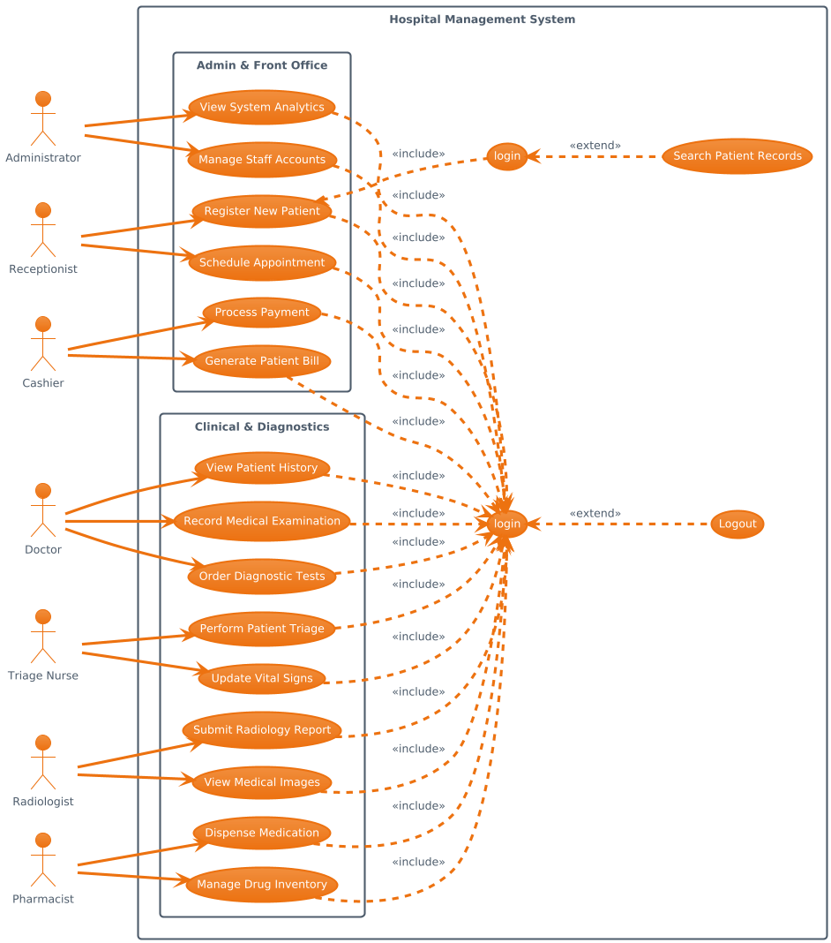

Figure 2.1. General Use Case Diagram

      - Specific Use Case Diagrams

Triage Use Case
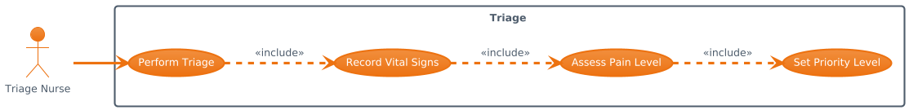

Figure 2.2. Triage Use Case

Reception Use Case
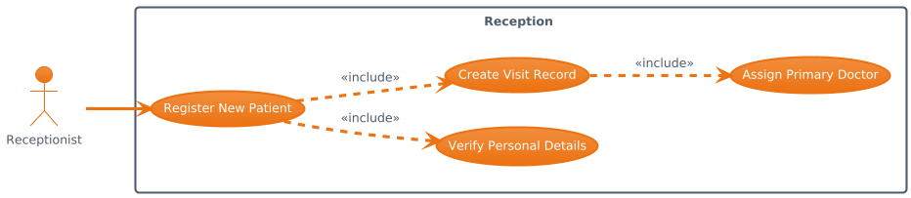

Figure 2.3. Reception Use Case

Doctor Use Case
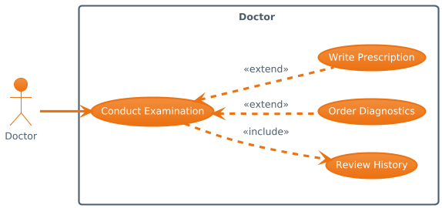

Figure 2.4. Doctor Use Case

Pharmacy Use Case
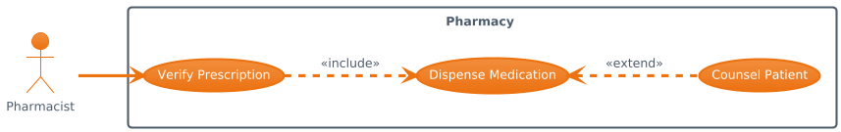

Figure 2.5. Pharmacy Use Case

- Billing Use Case

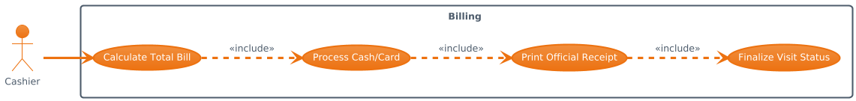

Figure 2.6. Billing Use Case
- Nurse Use Case
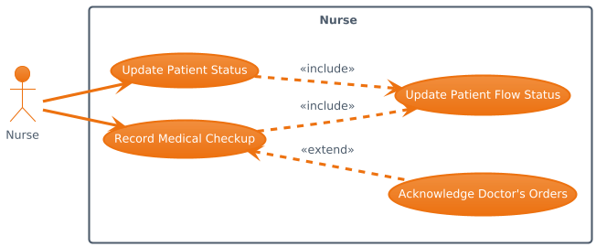
Figure 2.7. Nurse Use Case
- Laboratory Use Case
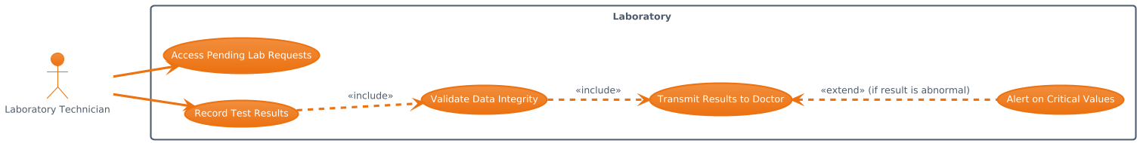
Figure 2.8. Laboratory Use Case

- Admin Use Case
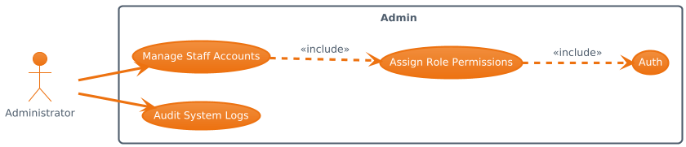
Figure 2.9. Admin Use Case

      - Use Case Documentations

Triage

Item | Description
Use Case ID | UC-01
Use Case Name | Triage
Primary Actor | Triage Officer
Description | Assesses and categorizes patients based on urgency before registration.
Preconditions | Triage officer is authenticated.
Post conditions | Patient triage level is recorded in the system.
Main Flow | 1. Triage officer selects new patient.  2. Records vital signs and symptoms.  3. Assigns triage category.  4. System saves triage information.
Alternative Flow | Incomplete assessment data prevents saving.

Table 2.1. Triage Use Case

Reception

Item | Description
Use Case ID | UC-02
Use Case Name | Reception
Primary Actor | Receptionist
Description | Registers patients and creates visit records after triage.
Preconditions | Triage must be completed. Receptionist is authenticated.
Post conditions | Patient is registered and visit is created.
Main Flow | 1. Receptionist searches or registers patient.  2. Confirms triage completion.  3. Creates patient visit.  4. System assigns visit and queue number.
Alternative Flow | Existing patient record is retrieved instead of creating a new one.

Table 2.2. Reception Use Case

- Doctor

Item | Description
Use Case ID | UC-03
Use Case Name | Doctor
Primary Actor | Doctor
Description | Performs medical consultation and records diagnosis and treatment.
Preconditions | Active patient visit exists.
Post conditions | Medical record is updated.
Main Flow | 1. Doctor views assigned patient list.  2. Selects patient visit.  3. Reviews medical history and triage info.  4. Records diagnosis and treatment plan.  5. Saves medical record.
Alternative Flow | Doctor requests laboratory tests before finalizing diagnosis.

Table 2.3. Doctor Use Case

Nurse

Item | Description
Use Case ID | UC-04
Use Case Name | Nurse
Primary Actor | Nurse
Description | Assists in patient care and updates patient status.
Preconditions | Active patient visit exists.
Post conditions | Patient status is updated.
Main Flow | 1. Nurse views patient queue.  2. Updates patient status (e.g., waiting, in treatment).  3. System saves status update.
Alternative Flow | Unauthorized status change is rejected.

Table 2.4. Nurse Use Case

Pharmacy

Item | Description
Use Case ID | UC-05
Use Case Name | Pharmacy
Primary Actor | Pharmacist
Description | Dispenses medication based on doctor prescription.
Preconditions | Valid prescription exists in the system.
Post conditions | Medication dispensing is recorded.
Main Flow | 1. Pharmacist views prescriptions.  2. Selects patient prescription.  3. Dispenses medication.  4. System records dispensing details.
Alternative Flow | Prescription validation fails and dispensing is blocked.

Table 2.5. Pharmacy Use Case

Laboratory

Item | Description
Use Case ID | UC-06
Use Case Name | Laboratory
Primary Actor | Laboratory Technician
Description | Performs laboratory tests and records results digitally.
Preconditions | Laboratory test request exists.
Post conditions | Test results are saved and linked to patient record.
Main Flow | 1. Technician views test requests.  2. Performs laboratory test.  3. Records test results.  4. System updates patient record.
Alternative Flow | Invalid or incomplete test request delays processing.

Table 2.6. Laboratory Use Case

- Billing

Item | Description
Use Case ID | UC-07
Use Case Name | Billing
Primary Actor | Cashier
Description | Generates bills and processes patient payments.
Preconditions | Medical services are completed.
Post conditions | Bill is generated and payment status is updated.
Main Flow | 1. Cashier selects completed visit.  2. System calculates charges.  3. Bill is generated.  4. Payment is processed and recorded.
Alternative Flow | Payment failure keeps bill unpaid.

Table 2.7. Billing Use Case

Admin

Item | Description
Use Case ID | UC-08
Use Case Name | Admin
Primary Actor | Administrator
Description | Manages users, system configuration, and reports.
Preconditions | Administrator is authenticated.
Post conditions | System data or configuration is updated.
Main Flow | 1. Admin manages users and roles.  2. Configures system settings.  3. Views operational and financial reports.
Alternative Flow | Unauthorized configuration changes are blocked.

Table 2.8. Admin Use Case

Business Rule Documentation
Business rules define the policies, constraints, and operational conditions that govern how the DOSE system functions within the hospital environment. These rules ensure consistency, correctness, and compliance with hospital workflows. They restrict how data is entered, processed, and accessed by different users and help enforce standardized procedures across the system.

Rule ID | Business Rule Description
BR-01 | Every patient must be registered before any medical service is provided.
BR-02 | A patient visit cannot be created unless the patient already exists in the system.
BR-03 | Each patient visit must be associated with exactly one patient and one department.
BR-04 | Only authorized healthcare providers (doctors or nurses) can update patient status.
BR-05 | Clinical checkups must be recorded before billing can be generated.
BR-06 | Billing amounts must be calculated based on predefined service charges.
BR-07 | Payments cannot be processed unless a bill has been generated.
BR-08 | Each system user must have exactly one role assigned.
BR-09 | Users can only access system functions permitted by their assigned role.
BR-10 | Patient medical records must not be deleted once created; only updates are allowed.
BR-11 | All financial transactions must be logged for auditing purposes.
BR-12 | System reports can only be viewed by administrators.
BR-13 | A patient visit must be closed before another visit for the same patient is created on the same day.

Table 2.9. Business Rule List

Business Rule ID | Affected System Function | Purpose
BR-01 | Register Patient | Ensures patient identity exists before service
BR-02 | Create Patient Visit | Prevents orphan visit records
BR-03 | Create Patient Visit | Maintains visit integrity
BR-04 | Update Patient Status | Ensures authorized medical control
BR-05 | Record Checkup / Generate Bill | Prevents billing without medical service
BR-06 | Generate Bill | Ensures standardized pricing
BR-07 | Process Payment | Prevents invalid financial records
BR-08 | Manage Users | Enforces role-based access
BR-09 | System Access Control | Protects sensitive data
BR-10 | Medical Record Management | Preserves patient history
BR-11 | Billing & Payment | Enables accountability
BR-12 | Reporting Module | Secures management data
BR-13 | Visit Management | Prevents duplicate visit entries

Table 2.10. Business Rules Mapped to System Functions

User Role | Applicable Business Rules
Administrator | BR-08, BR-09, BR-11, BR-12
Receptionist | BR-01, BR-02, BR-03, BR-13
Doctor | BR-04, BR-05, BR-10
Nurse | BR-04, BR-10
Cashier | BR-06, BR-07, BR-11

Table 2.11. Business Rules by User Role

User Interface prototype

Login Page
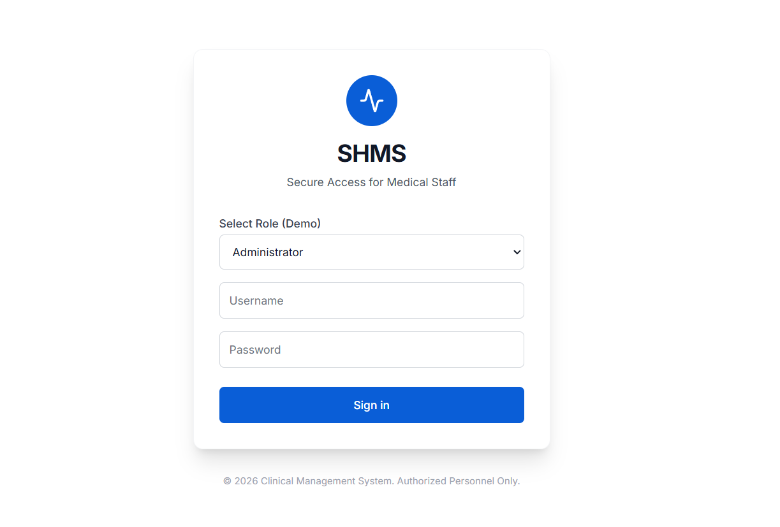

Figure 2.10 Login Page

Admin Dashboard
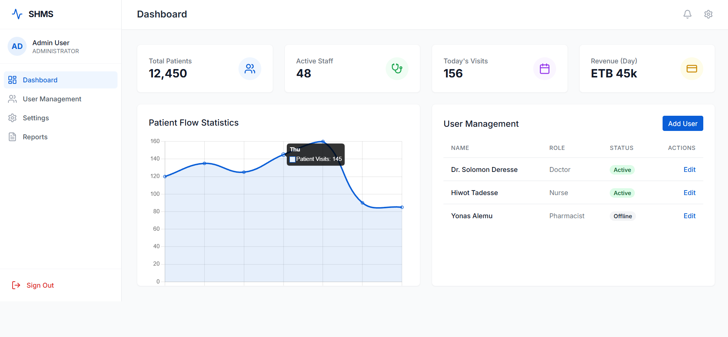
Figure 2.11 Admin Dashboard

Doctor Dashboard
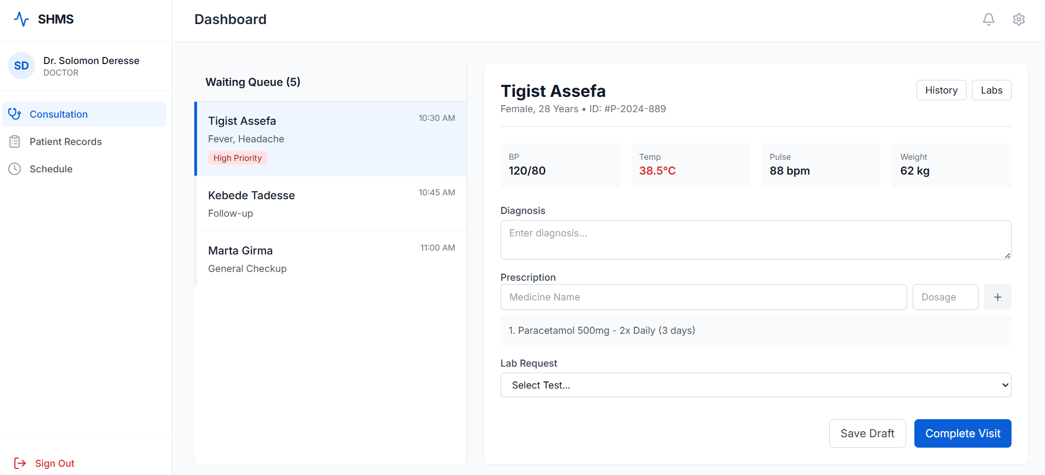
Figure 2.12 Doctor Dashboard

Payment Page
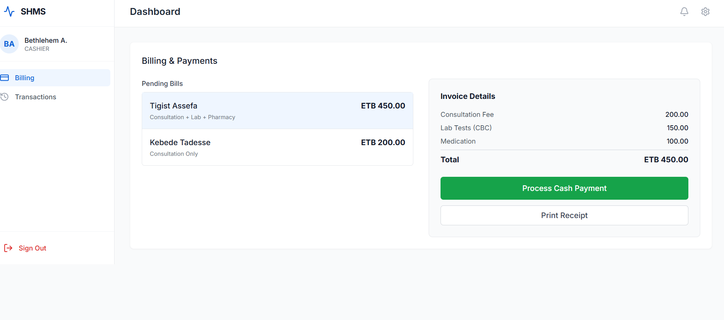

Figure 2.13 Payment Page

State chart diagram
      - Triage State Diagram
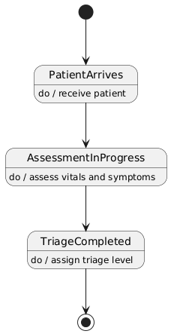

Figure 2.14 Triage State Diagram
      - Reception State Diagram
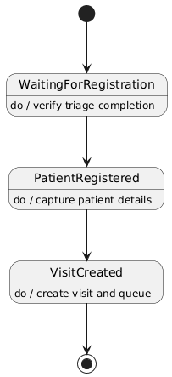

Figure 2.15 Reception State Diagram

      - Doctor State Diagram
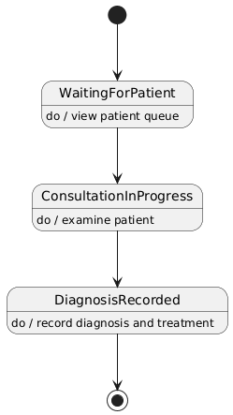

Figure 2.16 Doctor State Diagram

      - Nurse State Diagram
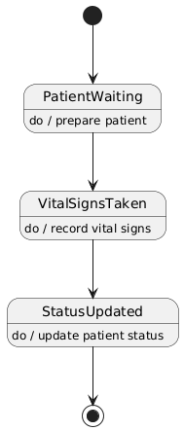

Figure 2.17 Nurse State Diagram

      - Pharmacy State Diagram
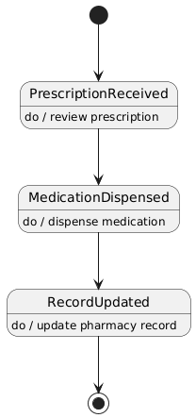
Figure 2.18 Pharmacy State Diagram

      - Laboratory State Diagram

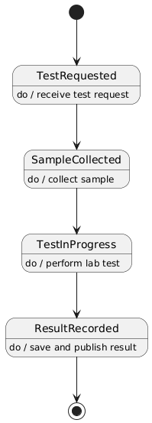

Figure 2.19 Laboratory State Diagram

      - Billing State Diagram
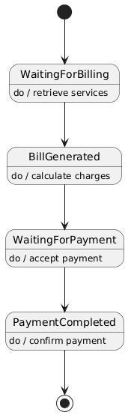
Figure 2.20 Billing State Diagram
      - Admin State Diagram

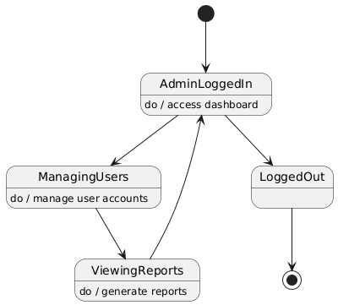
Figure 2.21 Admin State Diagram

Activity Diagram

Triage Activity Diagram
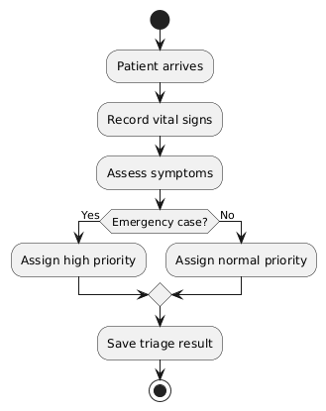

Figure 2.22 Triage Activity Diagram

Reception Activity Diagram
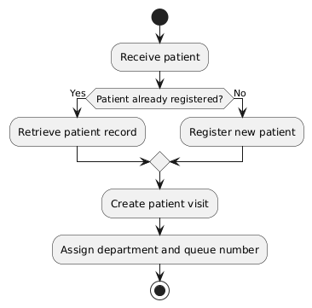

Figure 2.23 Reception Activity Diagram

Doctor Activity Diagram
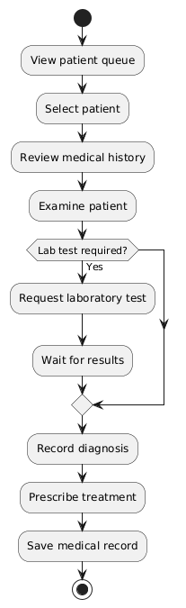

Figure 2.24 Doctor Activity Diagram

Nurse Activity Diagram
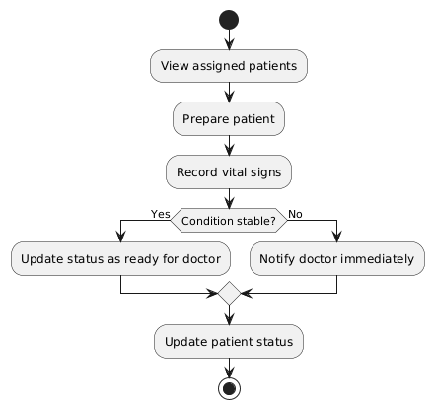

Figure 2.25 Nurse Activity Diagram

Pharmacy Activity Diagram
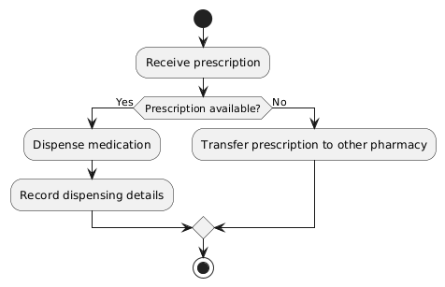
Figure 2.26 Pharmacy Activity Diagram

Laboratory Activity Diagram
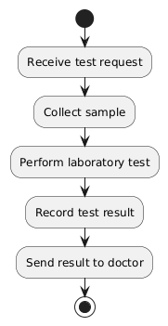
Figure 2.27 Laboratory Activity Diagram

Billing Activity Diagram
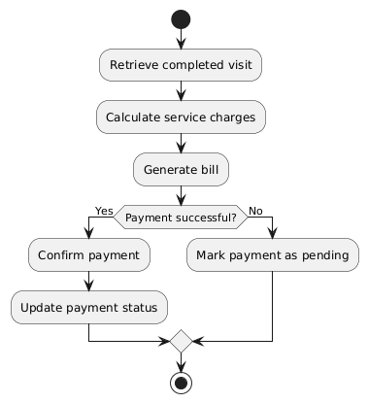
Figure 2.28 Billing Activity Diagram

Admin Activity Diagram
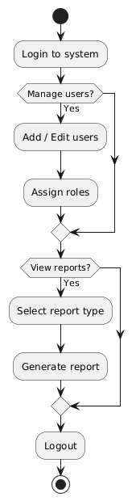
Figure 2.29 Admin Activity Diagram

Sequence diagram

Triage Sequence Diagram
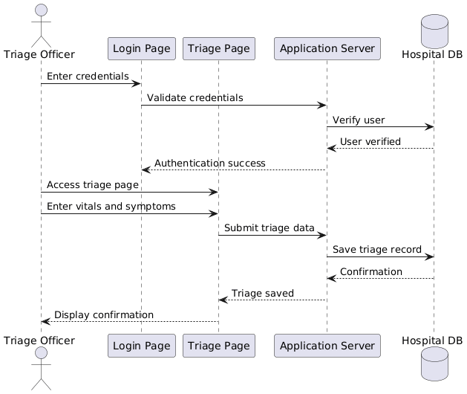

Figure 2.30 Triage Sequence Diagram

Reception Sequence Diagram
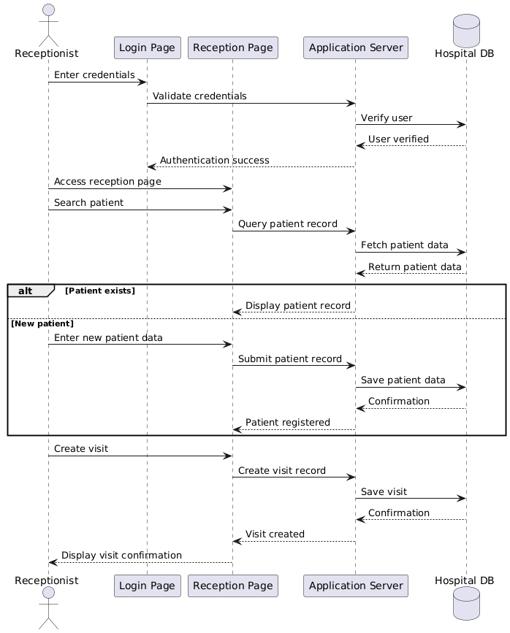

Figure 2.31 Reception Sequence Diagram

Doctor Sequence Diagram
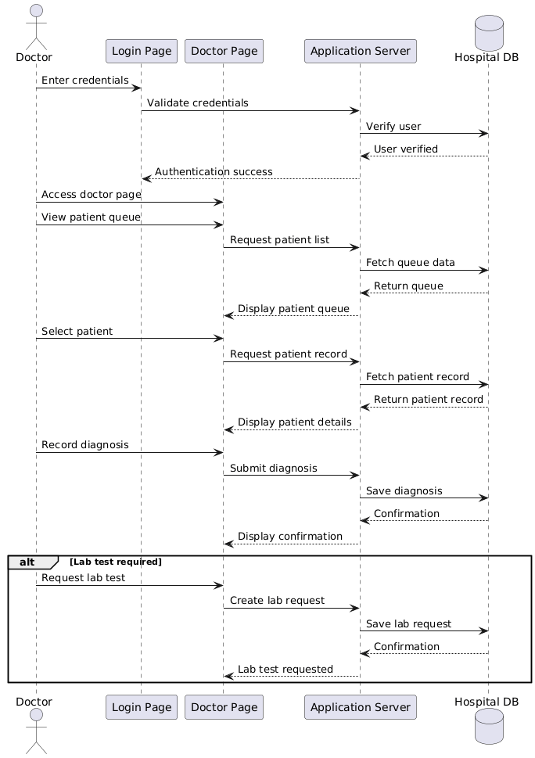

Figure 2.32 Doctor Sequence Diagram

Nurse Sequence Diagram
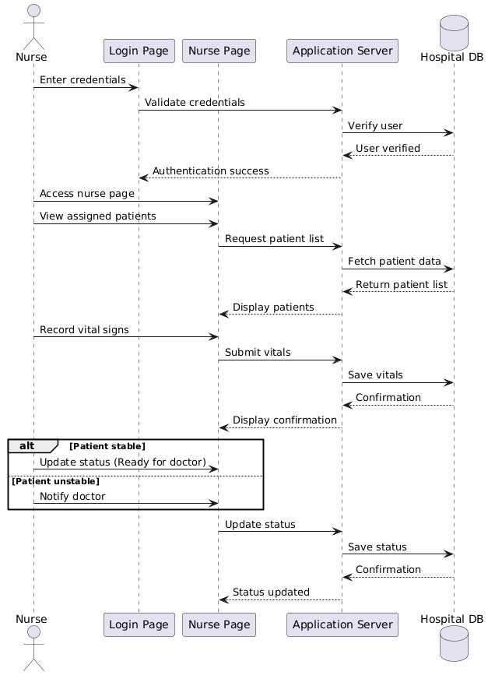
Figure 2.33 Nurse Sequence Diagram

Pharmacy Sequence Diagram

Figure 2.34 Pharmacy Sequence Diagram

Laboratory Sequence Diagram
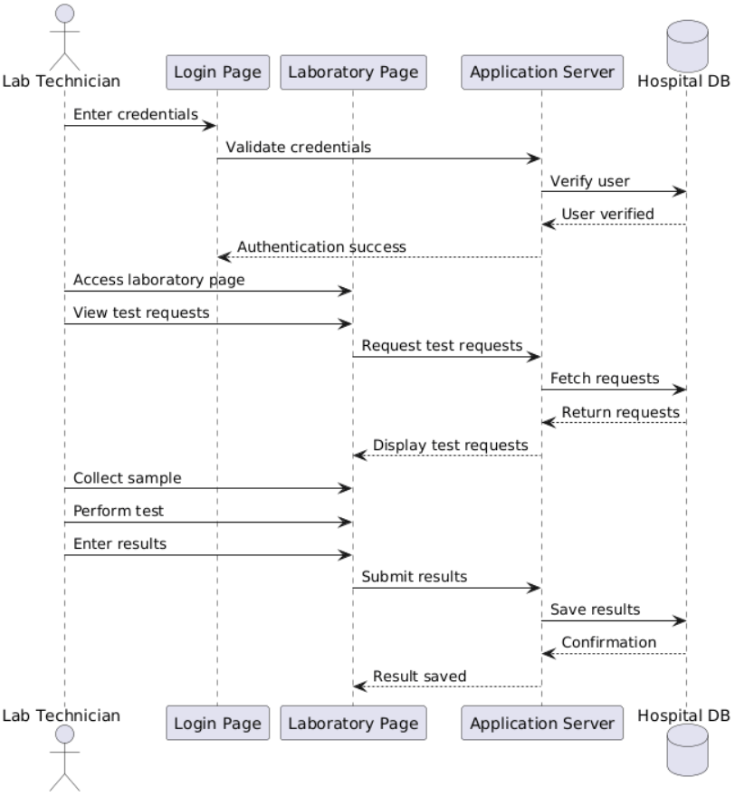
Figure 2.35 Laboratory Sequence Diagram

Billing Sequence Diagram
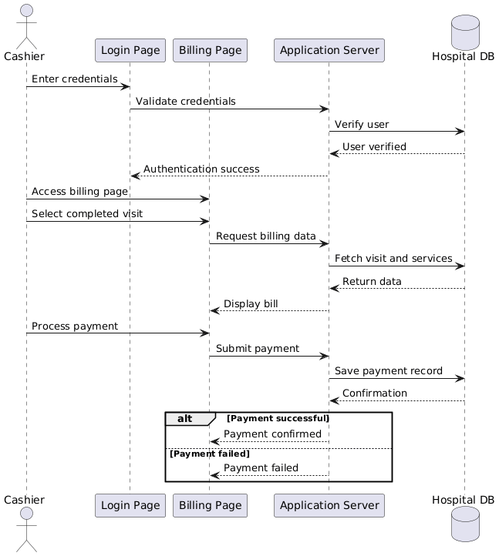
Figure 2.36 Billing Sequence Diagram

Admin Sequence Diagram
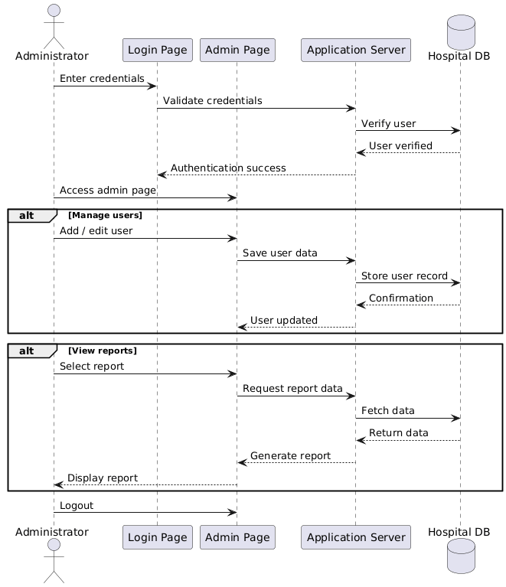
Figure 2.37 Admin Sequence Diagram

Analysis Class Model
The following classes represent the main entities involved in the DOSE system:

Class Name | Description | Key Responsibilities
User | Represents system users such as administrator,  receptionist, doctor, nurse, and cashier | Authentication, system access,  role assignment
Role | Defines user permissions and access levels | Permission control, role-based  authorization
Patient | Stores patient personal and identification details | Patient identity management,  record linking
Visit | Represents a patient’s hospital visit | Visit lifecycle tracking, queue management
Medical Record | Holds clinical data and checkup information | Clinical documentation,  diagnosis recording
Bill | Contains billing details and service charges | Cost calculation, billing status  management
Payment | Records payment transactions | Payment processing, transaction  confirmation
Report | Represents system-generated analytical data | Data aggregation, reporting,  decision support

Table 2.12 Core Classes and Their Responsibilities

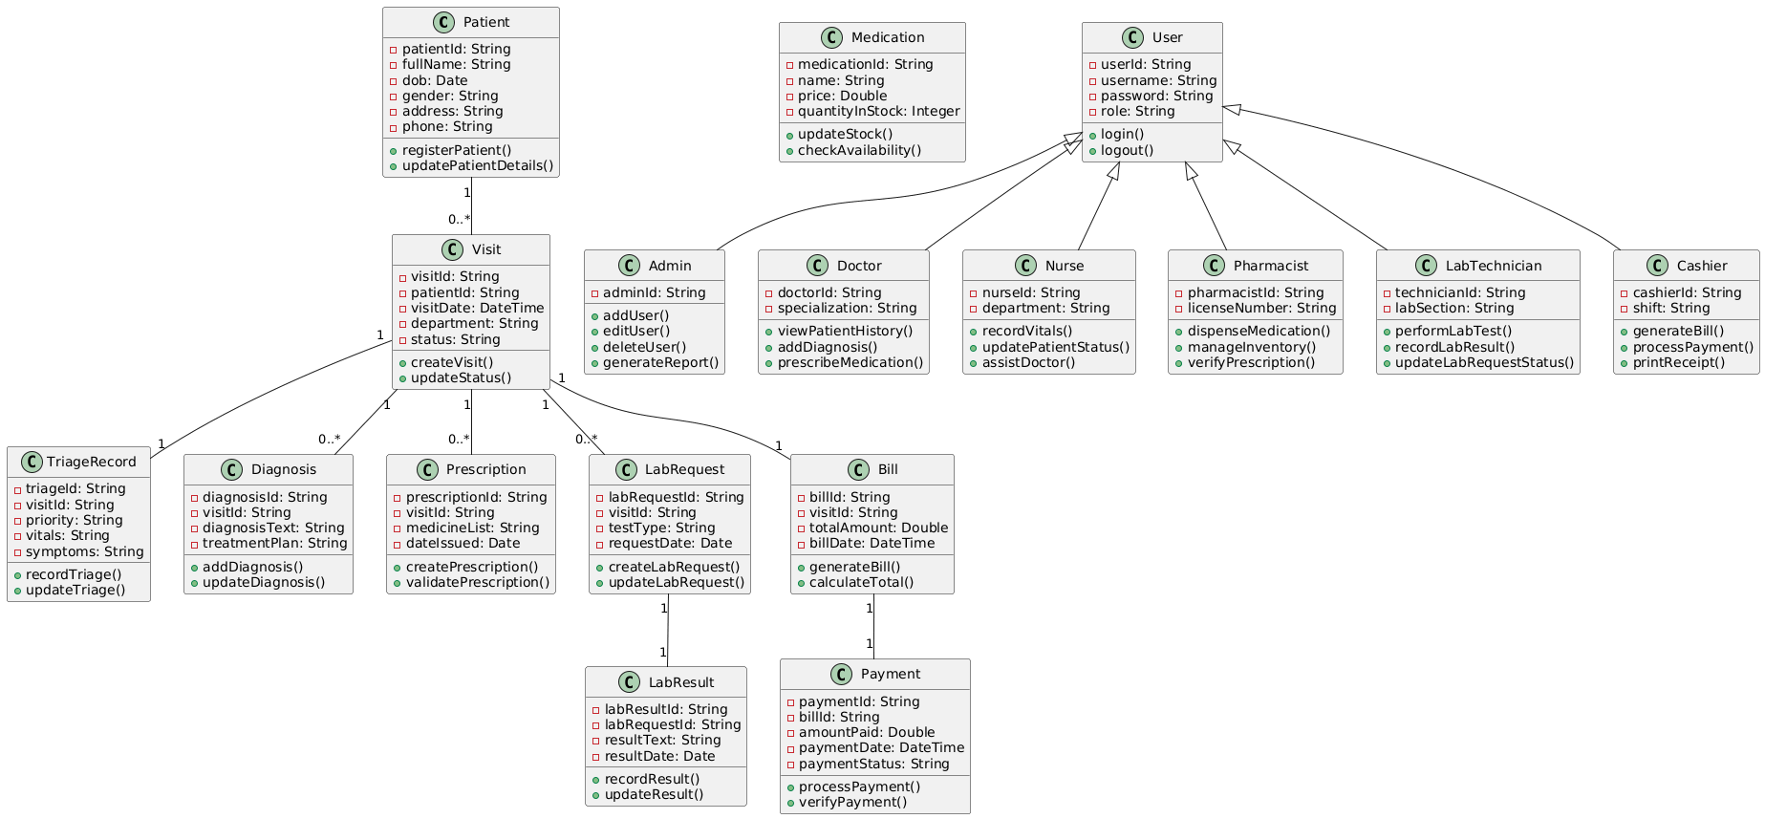

Figure 2.38 Analysis Class Diagram

Logic model

Input | Process | Output
Patient details | Register patient | Patient record
Patient ID | Create visit | Visit record & queue number
Checkup information | Record medical data | Medical record
Service list | Calculate charges | Generated bill
Payment data | Process payment | Payment confirmation
System data | Generate reports | Analytical reports

Table 2.13 Logic Model Table

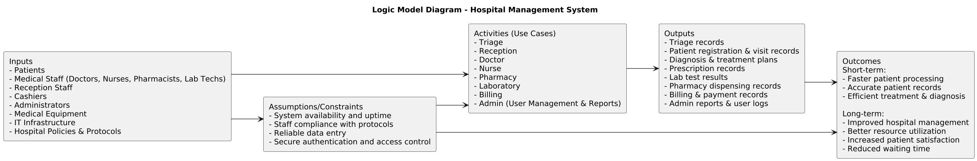

Figure 2.39 Logic Model Diagram

Nonfunctional requirement

Performance Requirements
      - The system shall respond to user requests within 3 seconds under normal operational load.
      - Patient registration and visit creation shall be completed in real time without noticeable delay.
      - The system shall support simultaneous users (administrators, doctors, receptionists, and cashiers) without performance degradation.
      - Report generation shall complete within an acceptable time even for large datasets.

Security Requirements
      - The system shall enforce role-based access control (RBAC) to restrict unauthorized actions.
      - User authentication shall require valid credentials before system access is granted.
      - Patient medical records shall be protected from unauthorized viewing, modification, or deletion.
      - All financial transactions shall be securely recorded and protected against tampering.
      - The system shall automatically log out users after a period of inactivity.

Usability Requirements
      - The system interface shall be simple, intuitive, and easy to learn, even for users with limited technical experience.
      - All screens shall follow a consistent layout and navigation structure.
      - Form validation messages shall be clear and informative.
      - The system shall minimize the number of steps required to complete common tasks.
      - The interface shall be accessible on standard desktop browsers.

Reliability and Availability Requirements
      - The system shall be available during all hospital operating hours.
      - The system shall recover gracefully from unexpected failures without data loss.
      - All critical operations shall ensure data consistency and integrity.
      - The system shall maintain accurate records even in the event of partial system failures.

Scalability Requirements
      - The system shall be able to accommodate an increasing number of patients, visits, and transactions without major redesign.
      - Additional users and departments shall be supported as the hospital grows.
      - The system architecture shall allow future integration with other hospital systems.

Maintainability Requirements
      - The system shall be designed using modular components to simplify maintenance.
      - Source code shall be readable, well-documented, and follow standard coding practices.
      - System updates and enhancements shall be possible without disrupting existing functionality.

Portability Requirements
      - The system shall be deployable on common web servers.
      - The application shall be accessible through modern web browsers.
      - The system shall not depend on specialized hardware.

Legal and Ethical Requirements
      - The system shall maintain confidentiality of patient information.
      - Patient data shall be used strictly for medical and administrative purposes.
      - The system shall comply with general healthcare data protection principles.

System Requirements

Hardware Requirements

Server Requirements

      - Processor: Intel Core i5 or higher
      - Memory (RAM): Minimum 8 GB
      - Storage: Minimum 500 GB HDD or SSD
      - Network: Stable local area network and internet connectivity

Client (User) Machine Requirements

      - Processor: Intel Core i3 or equivalent
      - Memory (RAM): Minimum 4 GB
      - Storage: Minimum 250 GB HDD or SSD
      - Display: Minimum 1366 × 768 resolution
      - Input Devices: Keyboard and mouse

Software Requirements

Server-Side Software

      - Operating System: Linux (Ubuntu) or Windows Server
      - Backend Framework: Python with Django
      - Database Management System: PostgreSQL
      - Web Server: Gunicorn / Nginx or Apache

Client-Side Software

      - Web Browser: Google Chrome, Mozilla Firefox, or Microsoft Edge
      - Frontend Framework: React.js
      - UI Design Tool: Figma (for prototyping)

Development Tools

      - Code Editor / IDE: Visual Studio Code
      - Version Control System: Git
      - Diagram Modeling Tool: PlantUML
      - Documentation Tools: Microsoft Word

Key abstraction with CRC (Class Responsibility Collaborator) analysis

CRC Cards

CRC Card: Patient

Class | Responsibilities | Collaborators
Patient | - Store patient personal data  - Update patient information  - Retrieve patient history | Visit, Triage Record, Diagnosis, Prescription, Lab Request, Bill

Table 2.14 Patient CRC Card

CRC Card: Visit
Class | Responsibilities | Collaborators
Visit | - Create visit record  - Track visit status  - Link patient to visit | Patient, TriageRecord, Diagnosis, Prescription, LabRequest, Bill

Table 2.15 Visit CRC Card

CRC Card: TriageRecord
Class | Responsibilities | Collaborators
TriageRecord | - Record vitals and symptoms  - Assign priority level  - Save triage results | Visit, Patient

Table 2.16 TriageRecord CRC Card

CRC Card: Diagnosis
Class | Responsibilities | Collaborators
Diagnosis | - Record diagnosis details  - Provide treatment plan  - Update medical history | Visit, Doctor

Table 2.17 Diagnosis CRC Card

CRC Card: Prescription
Class | Responsibilities | Collaborators
Prescription | - Create prescription for patient  - Validate prescription  - Link to visit | Visit, Pharmacist, Medication

Table 2.18 Prescription CRC Card

CRC Card: LabRequest
Class | Responsibilities | Collaborators
LabRequest | - Create lab test request  - Track test status  - Send request to lab | Visit, LabResult, LabTechnician

Table 2.19 LabRequest CRC Card

CRC Card: LabResult
Class | Responsibilities | Collaborators
LabResult | - Record lab test results  - Link results to lab request  - Provide results to doctor | LabRequest, Doctor

Table 2.20 LabResult CRC Card

CRC Card: Medication
Class | Responsibilities | Collaborators
Medication | - Manage inventory  - Check availability  - Update stock after dispensing | Prescription, Pharmacist

Table 2.21 Medication CRC Card

CRC Card: Bill

Class | Responsibilities | Collaborators
Bill | - Generate bill based on services  - Calculate totals  - Provide billing summary | Visit, Payment, Pharmacy, LabRequest

Table 2.22 Bill CRC Card

CRC Card: Payment
Class | Responsibilities | Collaborators
Payment | - Process payments  - Validate payment status  - Update billing status | Bill, Cashier

Table 2.23 Payment CRC Card

CRC Card: User
Class | Responsibilities | Collaborators
User | - Authenticate user login  - Manage user sessions  - Control access by role | Login Page, Admin

Table 2.24 User CRC Card

CRC Card: Admin
Class | Responsibilities | Collaborators
Admin | - Add/Edit/Delete user accounts  - Assign roles and permissions  - Generate reports | User, Report, Database

Table 2.25 Admin CRC Card

CRC Card: Report
Class | Responsibilities | Collaborators
Report | - Generate operational reports  - Generate financial reports  - Export report data | Admin, Database

Table 2.26 Report CRC Card

Identifying Change Cases

Change Case | Affected Classes | Description
New user role | User, Admin | Adding new hospital staff roles such as specialist doctors or supervisors
Triage policy change | TriageRecord | Modifying patient priority and urgency assignment rules
Patient registration update | Patient, Visit | Adding or modifying patient demographic or visit-related information
Medical diagnosis update | Diagnosis, Prescription | Expanding diagnosis formats or treatment documentation
Laboratory test expansion | LabRequest, LabResult | Introducing new laboratory tests or result formats
Pharmacy inventory update | Medication, Prescription | Updating medication tracking and stock management rules
Billing rule change | Bill | Updating service pricing, discounts, or insurance policies
Payment method update | Payment | Supporting additional payment options such as mobile or card payments
New report types | Admin, Report | Introducing new operational or financial analytics reports
Table 2.27 Change Cases

User Interface Prototyping

Key UI Characteristics

- Role-based dashboards
- Clean and minimal medical design
- Clear navigation and consistent layout
- Form-based data entry with validation
- Real-time status indicators

Primary UI Screens

- Login screen
- Administrator dashboard
- Receptionist dashboard
- Patient registration and visit screens
- Doctor medical record screen
- Billing and payment screens
- Reporting and analytics screens

Chapter 3: System Design
The Hospital Management System is designed to support and automate the daily operational and clinical activities of a hospital environment. The primary purpose of the system is to improve efficiency, accuracy, and coordination among hospital departments such as triage, reception, medical consultation, laboratory services, pharmacy, billing, and administration. By digitizing these processes, the system reduces manual paperwork, minimizes human error, and ensures timely access to patient and operational data, thereby improving overall quality of healthcare service delivery.
Performance is a critical design consideration due to the time-sensitive nature of hospital operations. The system is designed to provide fast and consistent response times for key activities such as patient registration, triage assessment, diagnosis recording, and billing. Efficient data retrieval mechanisms and a centralized database ensure that frequently accessed information, such as patient records and visit histories, can be accessed quickly. The modular architecture allows multiple users to operate concurrently without degrading system performance, even during peak operational hours.
Dependability is another essential design goal, as the system must function reliably in a healthcare setting. The system ensures data integrity by storing all clinical and administrative information in a centralized and well-structured database. Authentication and authorization mechanisms ensure that only authorized users can access the system, while validation rules prevent incomplete or invalid data from being stored. These measures ensure continuous availability and reliable operation of the system, which is crucial in critical medical environments.
Security plays a central role in the system design because of the sensitive nature of medical and financial data. The system implements secure login mechanisms and role-based access control to restrict users to functionalities relevant to their responsibilities. This ensures that patient records, laboratory results, and billing information are protected from unauthorized access or modification, maintaining confidentiality and compliance with hospital data protection policies.
Usability is a key design goal, particularly because the system will be used by diverse hospital staff with varying technical backgrounds. The system provides role-based interfaces that present users with only the functionalities relevant to their roles, reducing complexity and cognitive load. Clear navigation structures and well-designed input forms make the system easy to learn and use, minimizing training requirements and reducing the likelihood of user errors during operation.
Scalability is incorporated into the system design to accommodate future growth and evolving hospital requirements. The system architecture allows new user roles, services, and functional modules to be added with minimal impact on existing components. This ensures that the system can adapt to increased patient volume, expanded hospital services, or changes in operational procedures over time.
Maintainability is achieved through a modular and well-organized system structure. Each major functional area, such as triage, billing, pharmacy, and administration, is designed as an independent module. This separation of concerns allows changes or enhancements to be made in one module without affecting the entire system. Clear system design and documentation further simplify system maintenance and future upgrades.

3.1. Architectural Design

3.1.1. Component Modeling

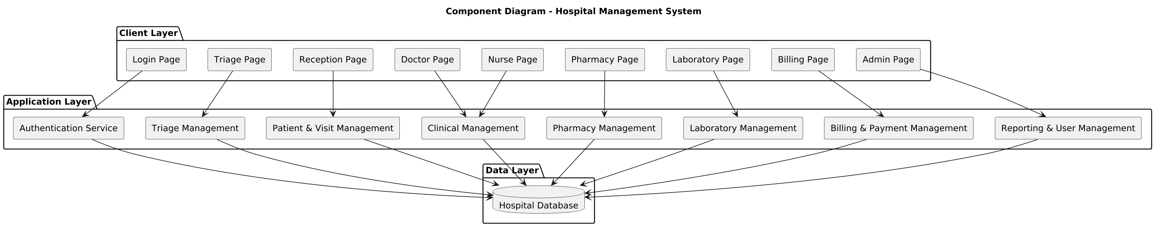
Figure 3.1 Component Model

3.1.2. Deployment Modeling

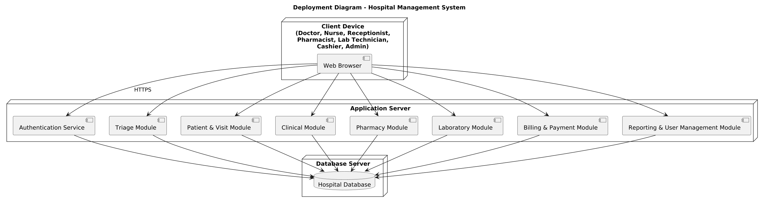
Figure 3.2 Deployment Model

3.2. Detail Design

3.2.1. Design Class Model

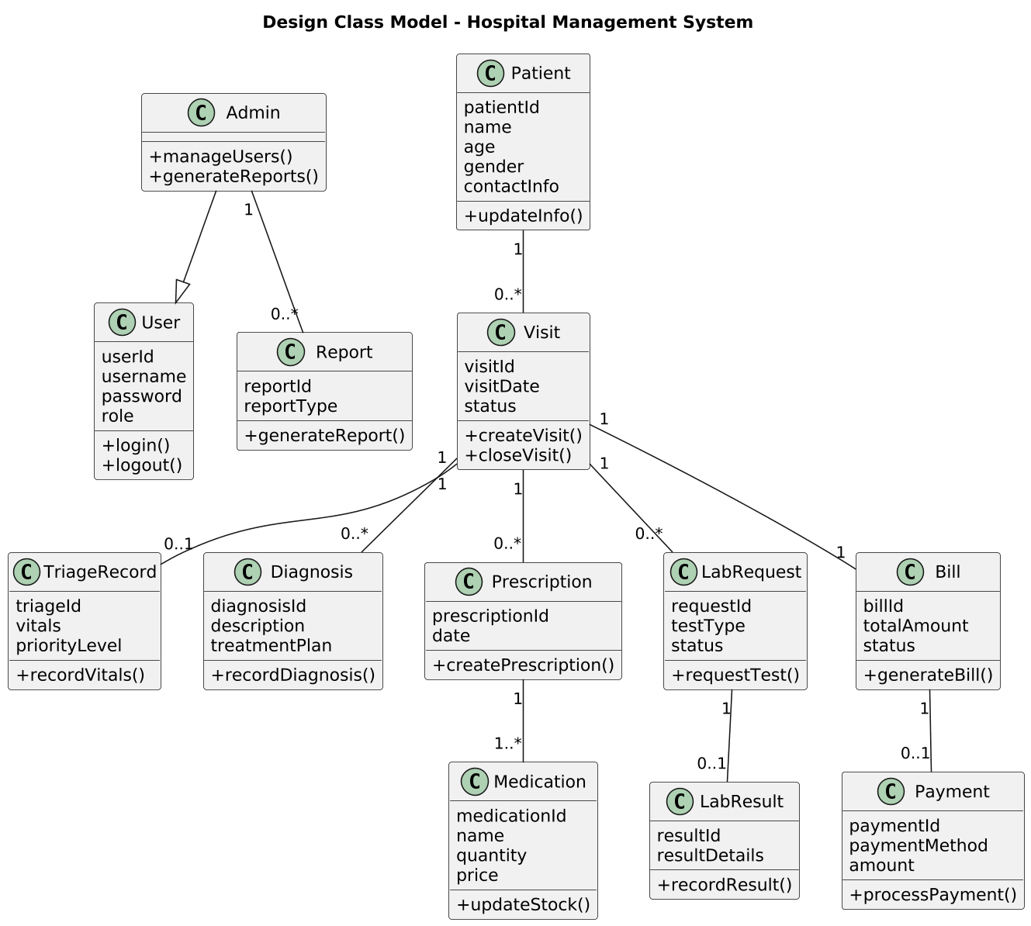
Figure 3.3 Deployment Model

3.2.2 Persistent Model

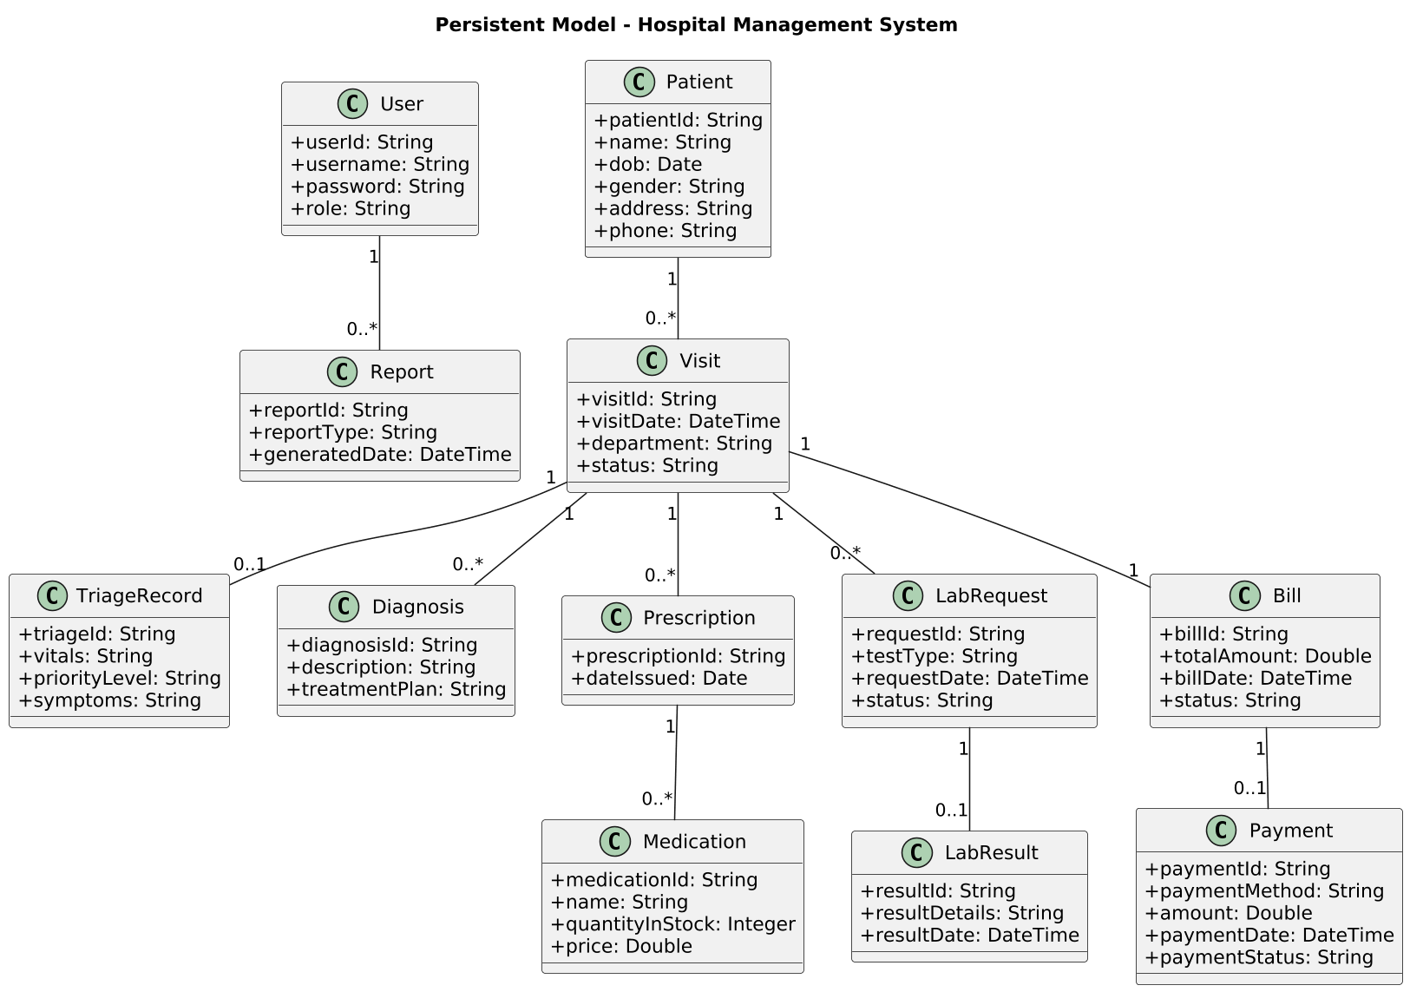
Figure 3.4 Persistent Model

3.3. User Interface Design

Login Page

Figure 3.5 Login Page

Admin Dashboard

Figure 3.6 Admin Dashboard

Doctor Dashboard

Figure 3.7 Doctor Dashboard

Payment Page


Figure 3.8 Payment Page

Reference
- Ethiopian Hospital Systems Research. (2024). Analysis of Existing Hospital Information Systems and Operational Challenges in Ethiopian Healthcare Institutions. Unpublished research document.
- Sommerville, I. (2016). Software Engineering (10thed.). Pearson Education.
- Pressman, R. S., & Maxim, B. R. (2019). Software Engineering: A Practitioner’s Approach (9thed.). McGraw-Hill Education.
- Object Management Group (OMG). (2017). Unified Modeling Language (UML) Specification.
- World Health Organization (WHO). (2018). Digital Health Interventions: Classification and Systematic Review.
- PlantUML. (n.d.). PlantUML Documentation. Retrieved from https://plantuml.com
- Figma. (n.d.). Figma Design Tool. Retrieved from https://www.figma.com

Appendix A: Interview Questions
The following questions were used during interviews with the system administrators of two hospitals. The aim was to understand how their existing hospital management system works and how a similar system can be developed.
- What modules are included in your current hospital management system?
- How do users (staff) log in and access the system?
- How is patient registration and visit handled?
- How are clinical records and treatment information managed?
- How are laboratory requests and results processed?
- How is pharmacy dispensing and medication management done?
- How are billing and payments handled?
- What reports are generated for hospital management?
- What security measures are implemented (authentication, access control)?

Appendix B: Interview Summary
The system administrators explained the structure and workflow of their existing hospital management system. They described how the system is designed with role-based access, where each staff member logs in and uses a specific module according to their role. They also explained that the system integrates patient registration, visit tracking, clinical documentation, laboratory processing, pharmacy dispensing, and billing into a unified workflow. The administrators guided us on how to build a similar system by emphasizing the importance of secure authentication, role-based dashboards, centralized data storage, and reporting capabilities. Their explanations helped shape the design and requirements of this project to match a real hospital environment.

